**Home Infrastructure Setup Project**

Active Directory, DNS & Computer Configuration

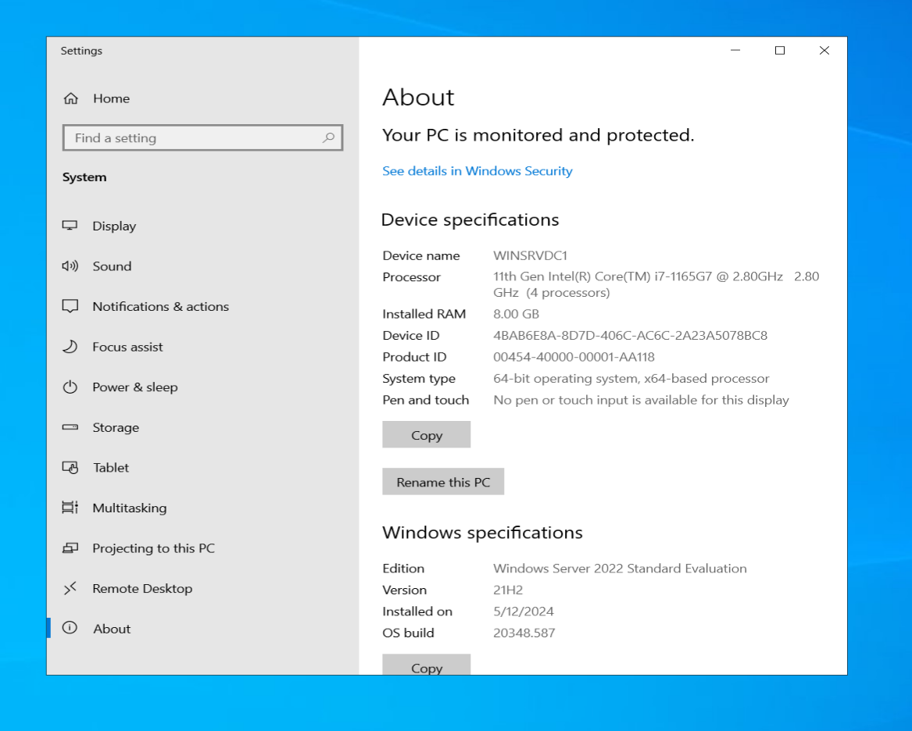

The first thing I did after I installed my windows server virtual machines was rename my computers so I know what’s what. This is on my first domain controller, the name is “WINSRVDC1”. How I changed the name was by opening control panel, then I clicked “system and security”, then “system”, then this screen came up. I clicked "rename this PC”, then I renamed it, and the VM restarted.

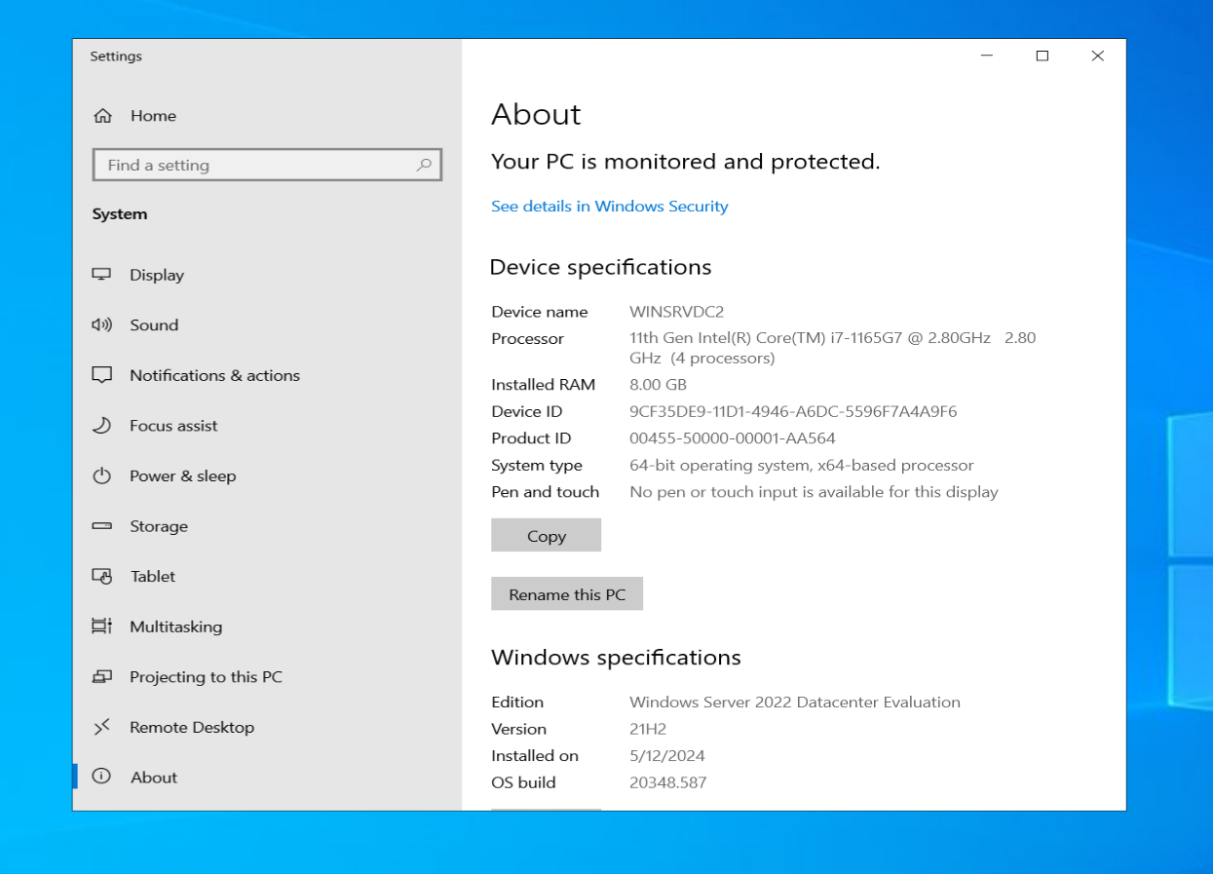

Domain Controller 2’s name, being “WINSRVDC2”.

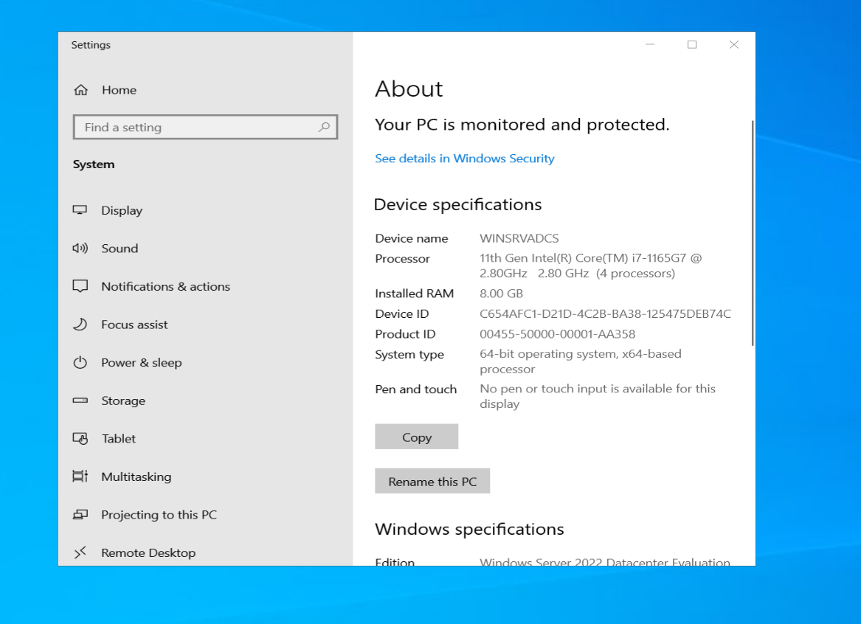

The server for Active Directory Certificate Services, being “WINSRVADCS”.

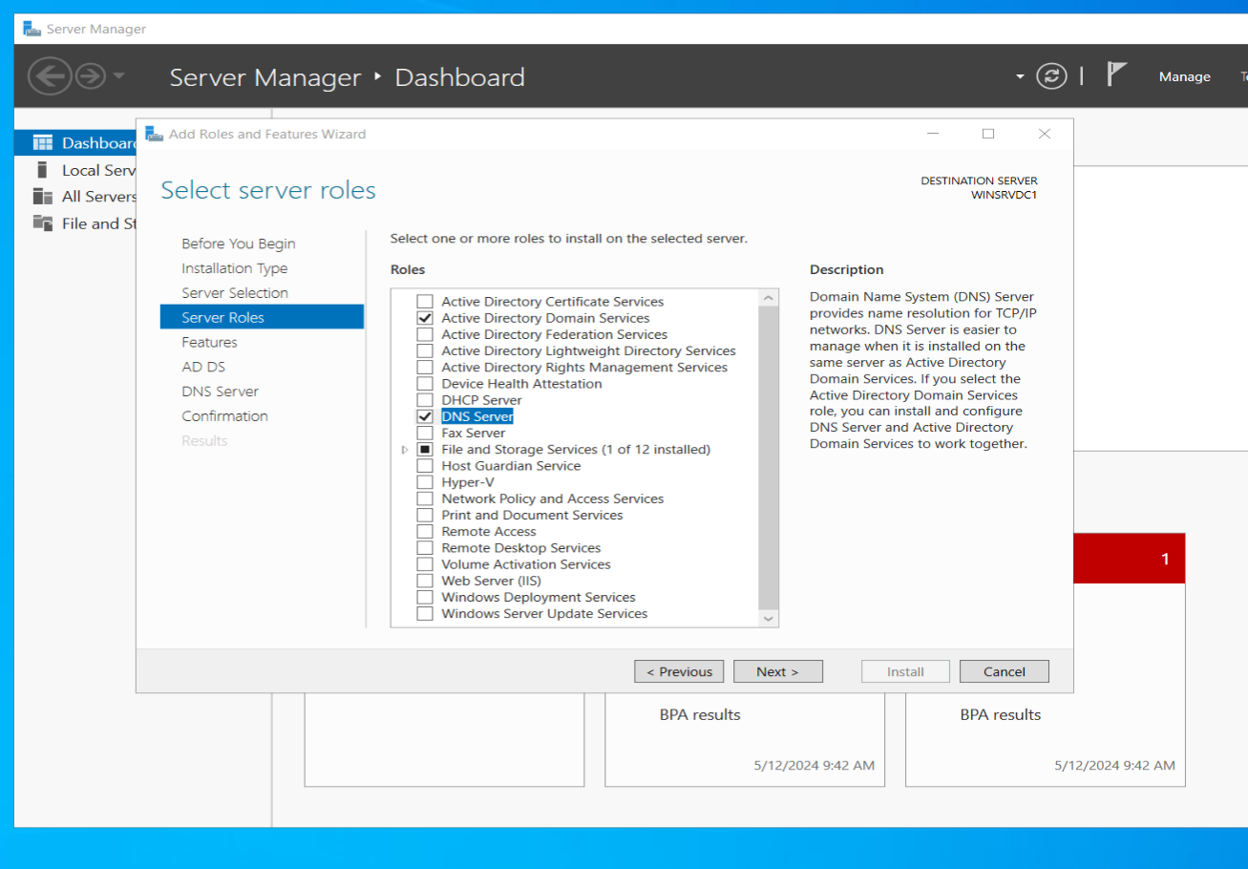

Then, in domain controller 1, I set up my server to be a domain controller by installing Active Directory Domain Services and DNS. This is done in Server Manager, adding roles and features, keeping the installation type default and the server selection being my server.

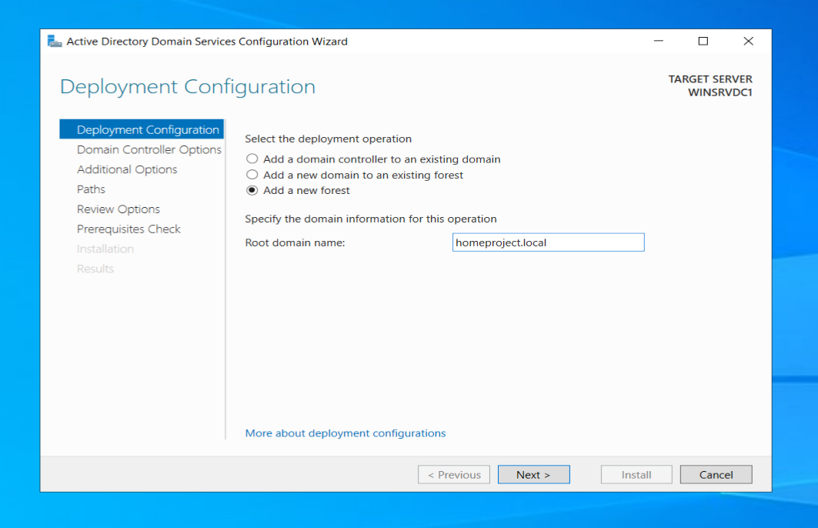

After the installation succeeded, I began to promote my server to a domain controller. The root domain name I am setting for this project is “homeforest.local”., not homeproject. Small typo.

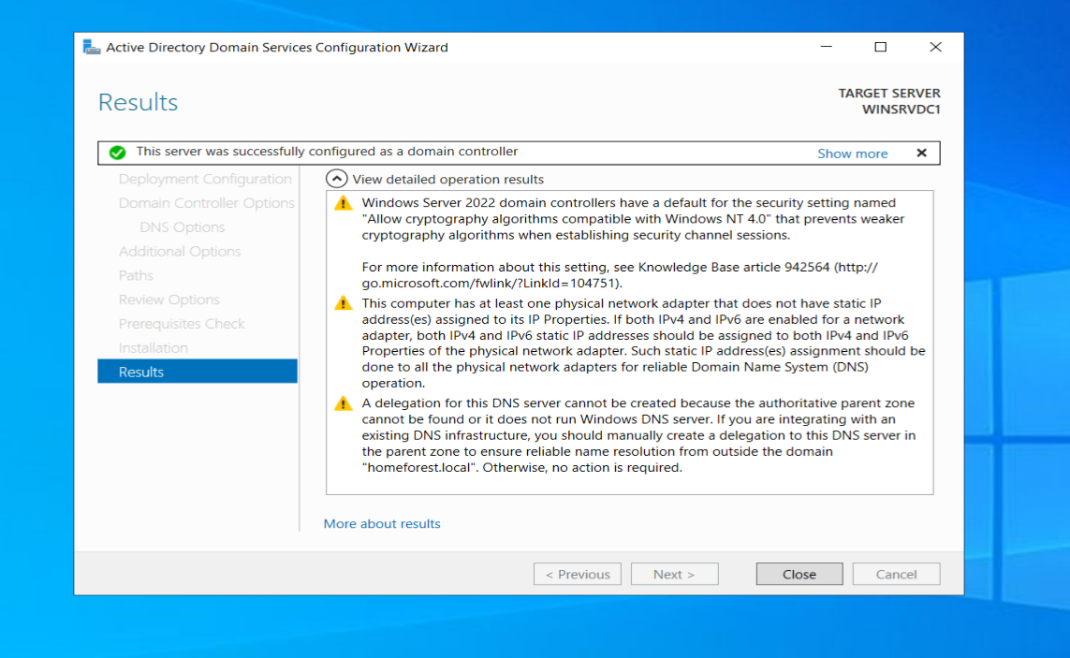

After configuring everything, this shows my configuration was successful as well as the installation.

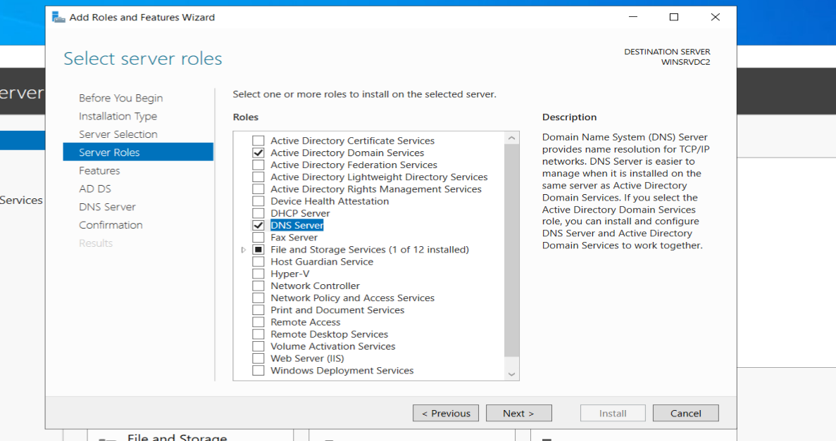

The next thing I did was the same process I did on my first domain controller. I first installed ADDS and DNS.

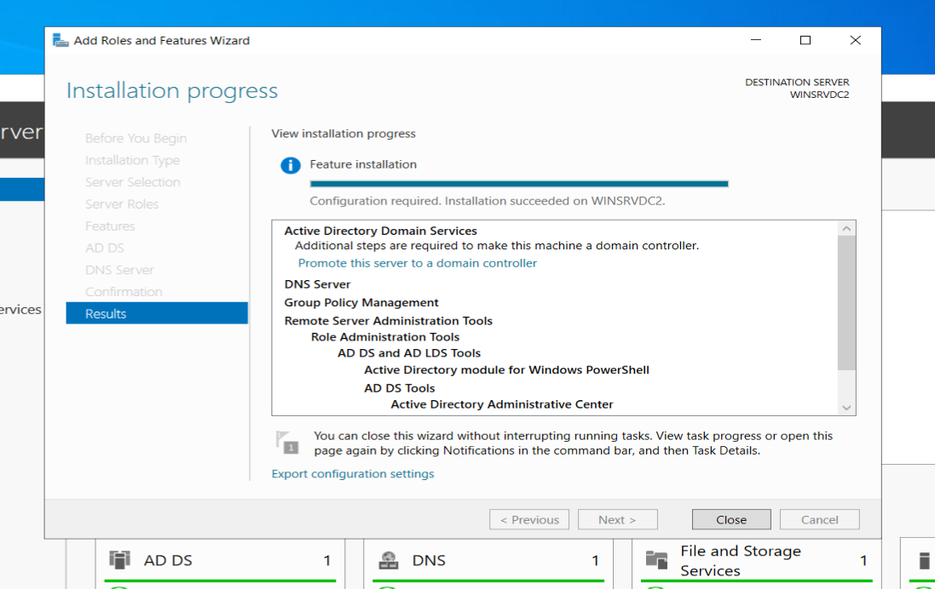

I also installed group policy management too, the same on domain controller 1. This windows show the installation was successful.

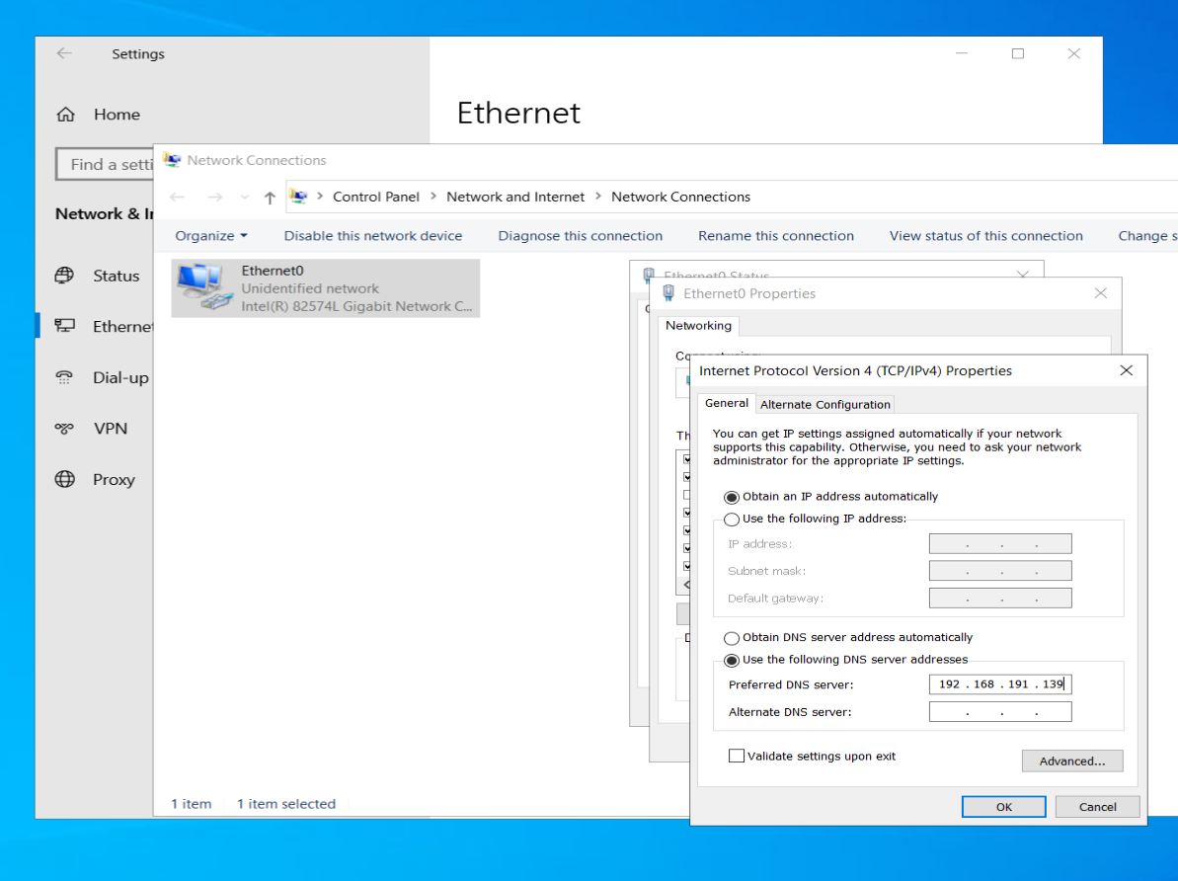

Then, I needed to join my second domain controller to my first domain controller. This was done by opening up network settings, ethernet, change adapter settings, clicking ethernet0, its status, ipv4 properties, and pointing my DNS to the IP of my first domain controller.

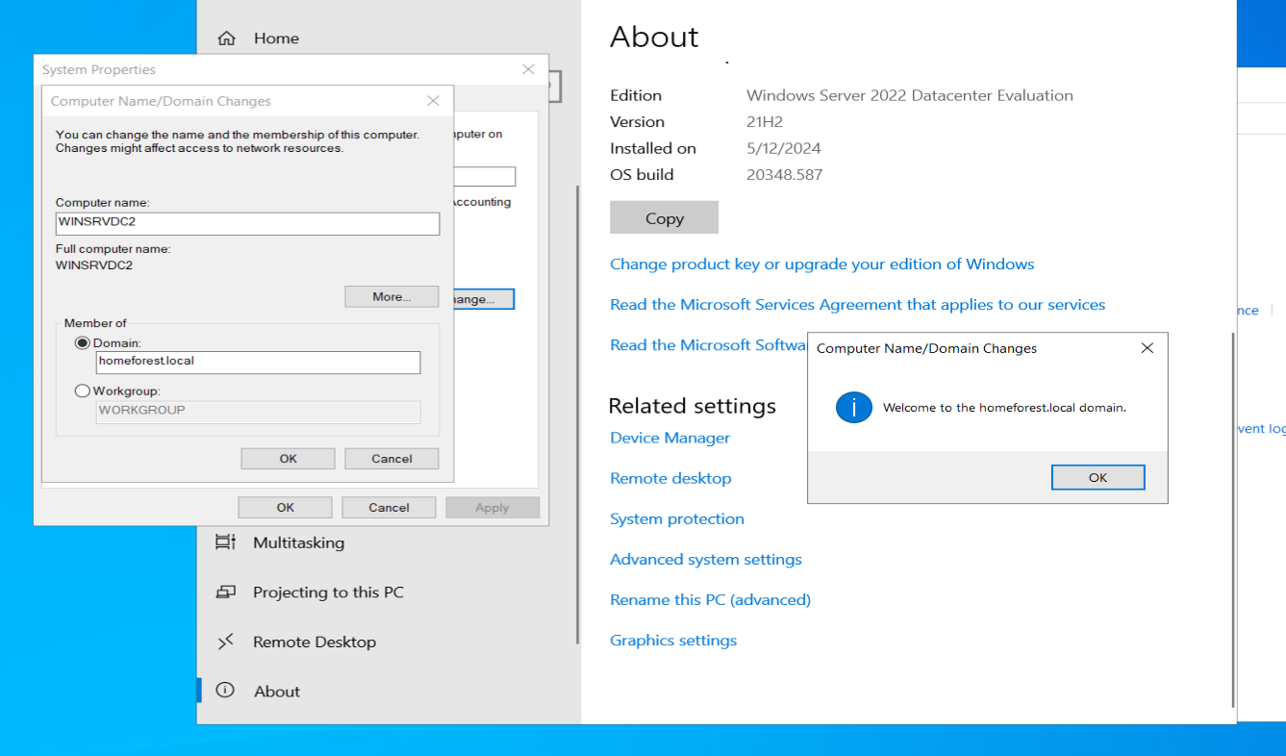

Then, I had to join my second domain controller to my first by going to control panel, and changing the name of my computer, only this time, clicking “rename this PC(Advanced)”, the change button in system properties, and where it says “member of”, typing the name of my domain. It asked for my credentials, username being “administrator” and my password. I then successfully joined my domain and my VM restarted.

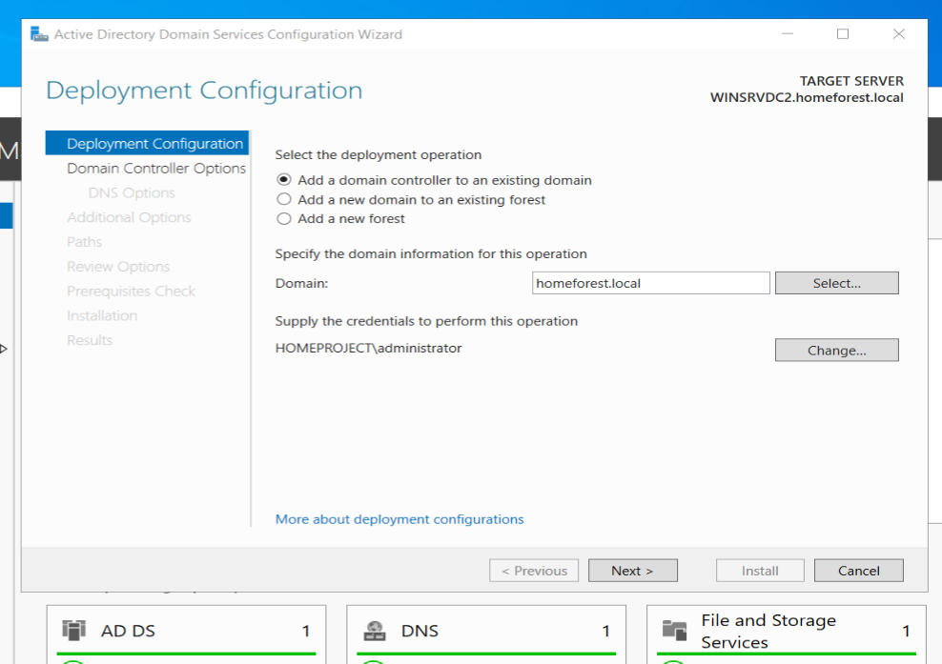

I then had to finish promoting my second domain controller to a domain. The domain name for this operation as it states is my domain I joined it to, “homeforest.local”. the credentials must be the name \adminstrator.

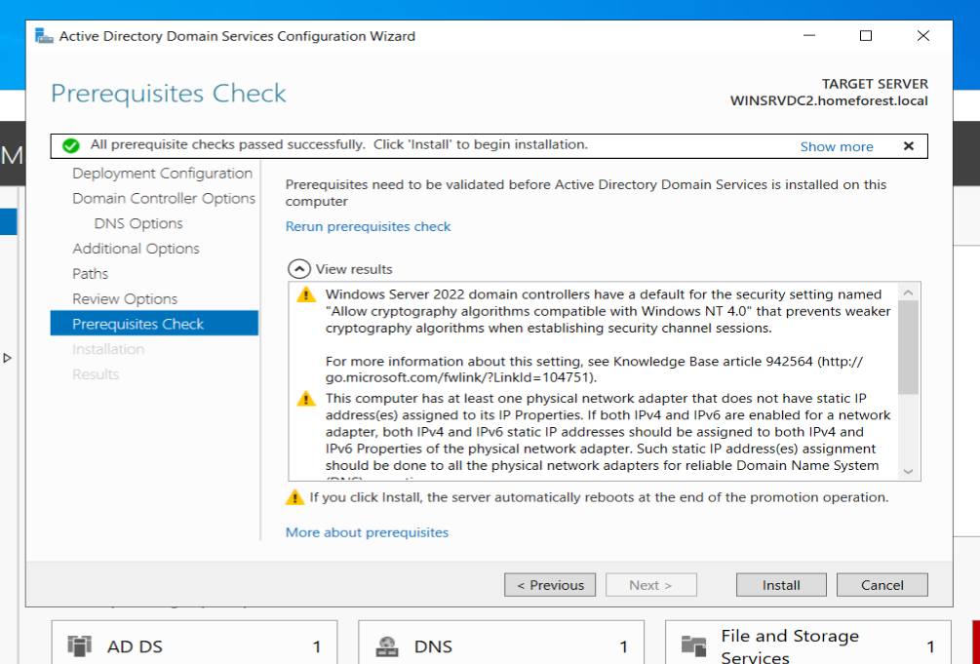

Before installation, this shows my prerequisites were configured properly.

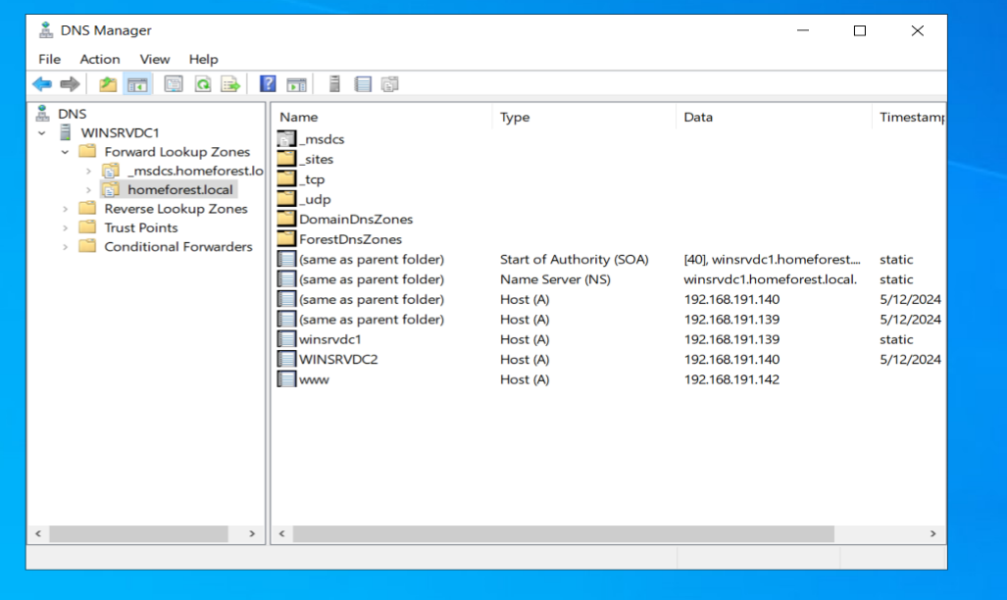

The next task I did was in DNS in domain controller 1, add a DNS entry named ‘www’ pointing back to my CentOS 7 machine. To do this, I opened DNS, clicked on forward lookup zones, my domain name, right clicked it, and created a new A record. I typed ‘www’, and then my CentOS 7 IP being 192.168.191.142.

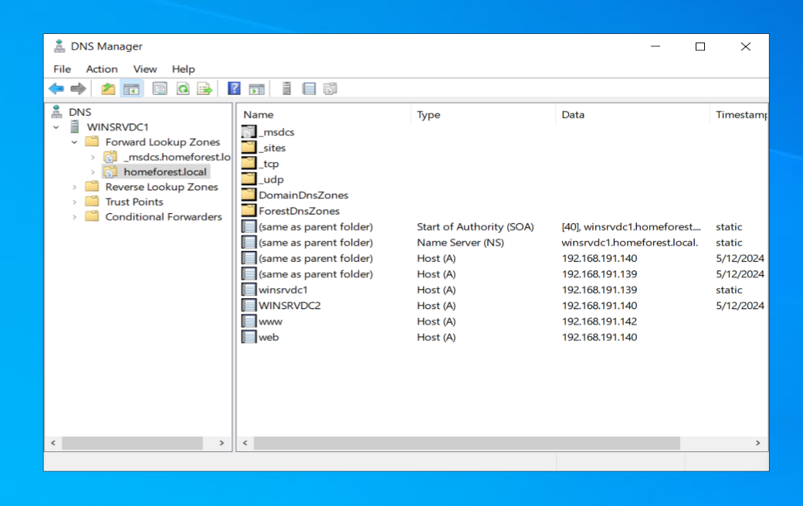

I also added an entry titled “web” for my IIS web server.

Group Policy Management

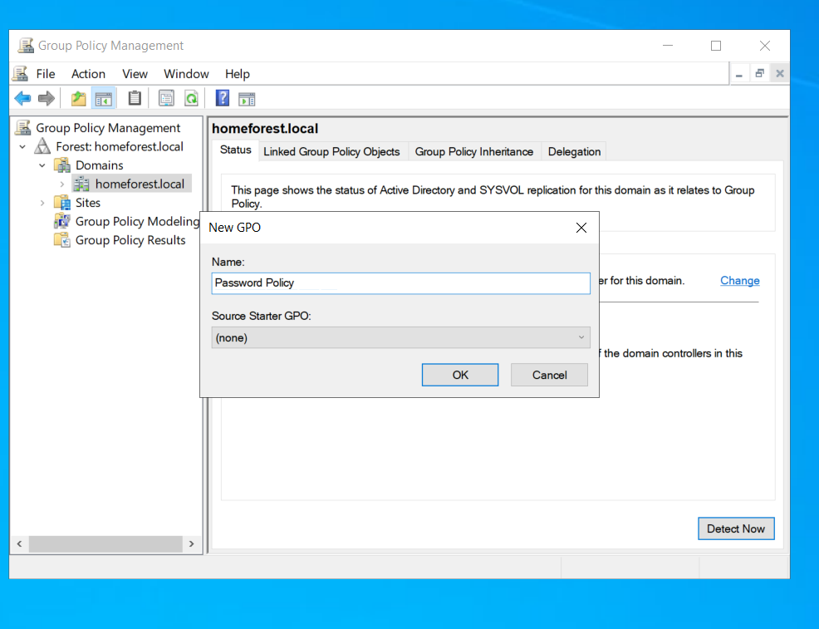

The first policy I implemented throughout my domain was creating a policy that when creating new users, their password must be at least 10 characters long. I did this by opening GPM, right clicking the name of my domain, clicking edit, and create a new GPO. The name in this case is Password Policy.

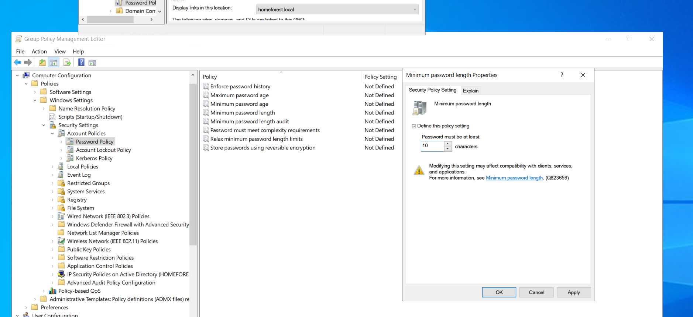

This policy was in computer configuration, windows settings, security settings, and password policy. The policy I needed to change was “Mininum password length properties”.

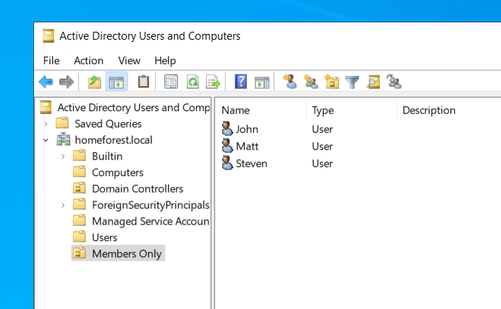

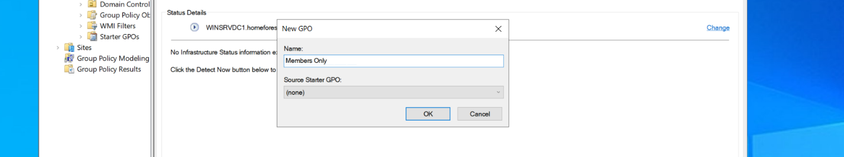The next thing I did was creating a new OU called Members Only. I created 3 users for this OU, named John, Matt, and Steven. How this was done was by opening Active Directory Users and Computers. I clicked my domain, right clicked it, and created a new OU, giving it its name. in the OU, I created my users by right clicking and selecting new, then user.

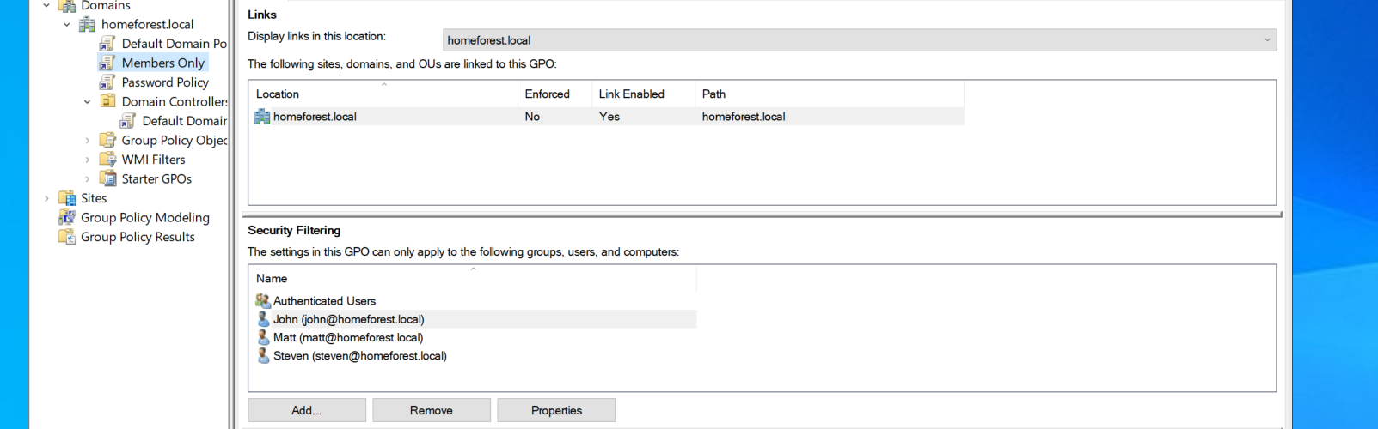

I then returned to Group Policy Management, and created a new policy called Members Only, and added my users to the Security Filtering section.

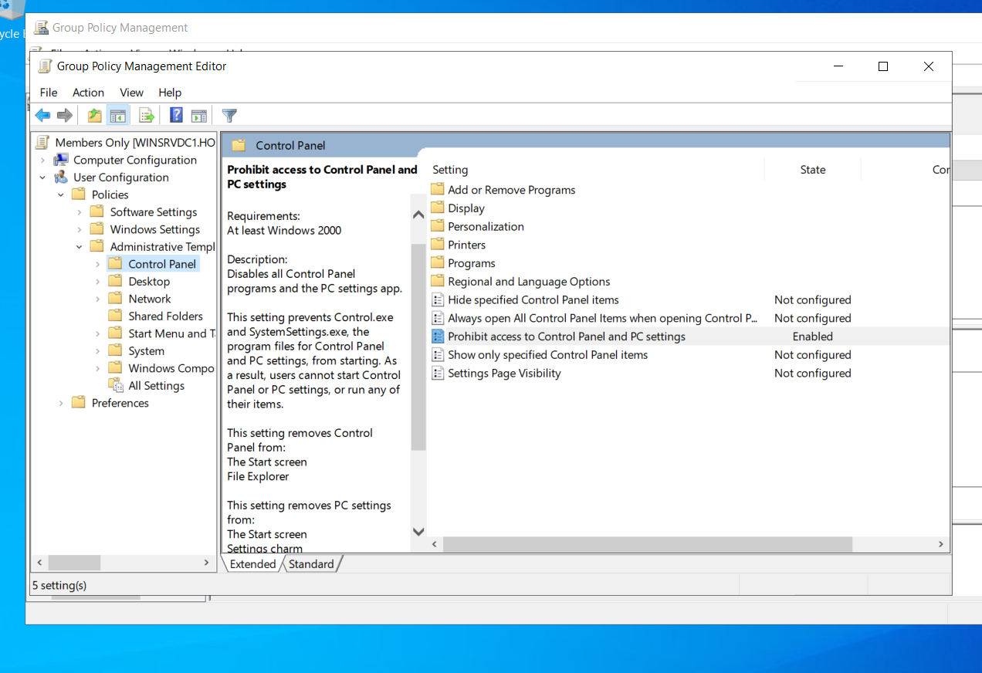

I added a policy for the users in my OU to prohibit control panel access. This policy was found in user configuration, administrative templates, and control panel. Where it says “prohibit access to control panel and PC settings” is where I enabled the setting.

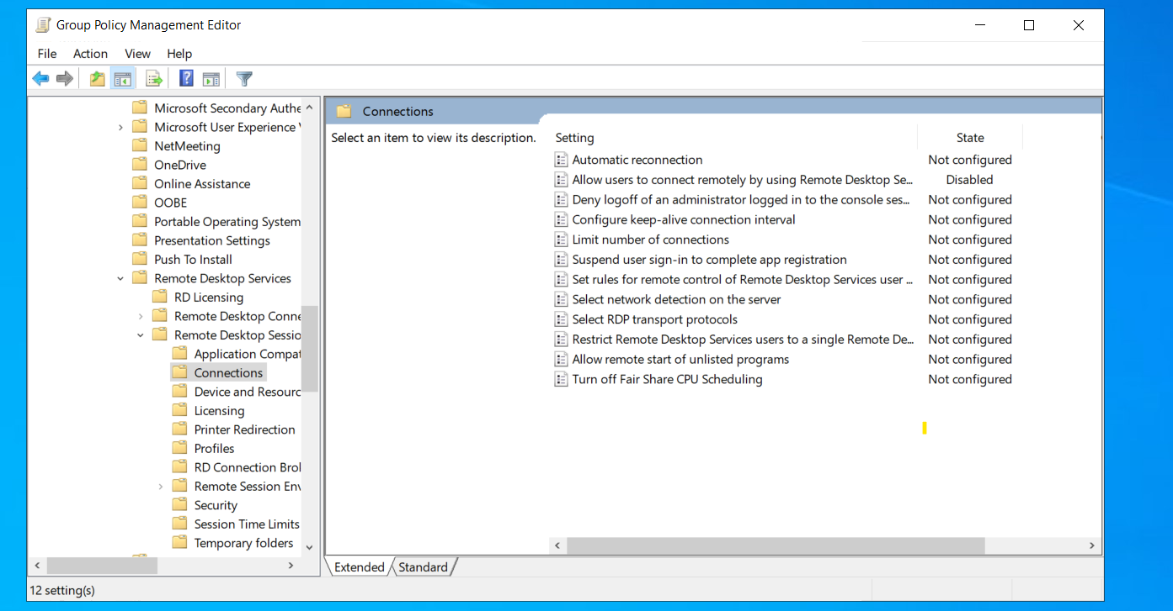

I also restricted the users in my OU to remote desktop connection. This policy was found in computer configuration, policies, administrative templates, windows components, remote desktop services, remote desktop session host, connections, and disabling the policy where it says, “allow users to connect remotely by using remote desktop services”.

Active Directory Certificate Services Setup

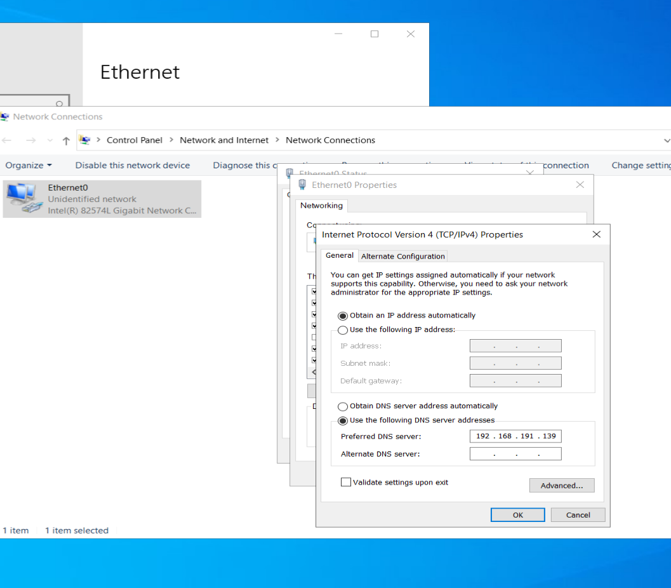

The first task I needed to do was on my windows server for ADCS, join that server to my main domain controller. I first needed to point DNS to my main domain controller in the network settings of this server. I explained how this was done before when joined my second domain controller.

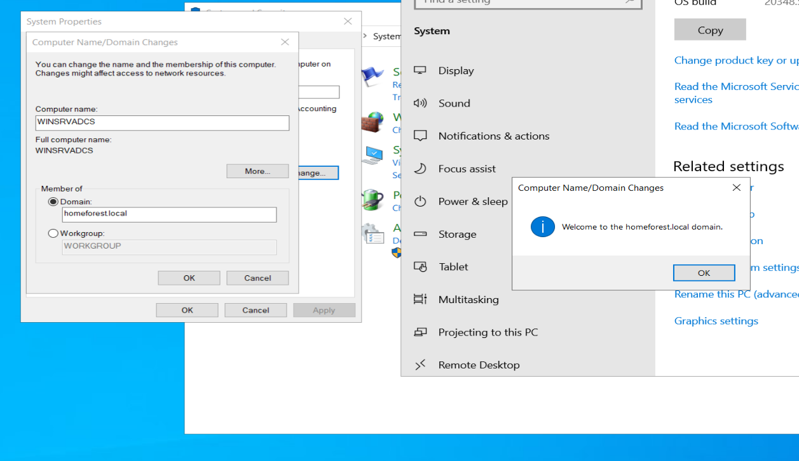

After pointing DNS to my main domain controller and changing the domain member how I did so for domain controller 2, the join was successful.

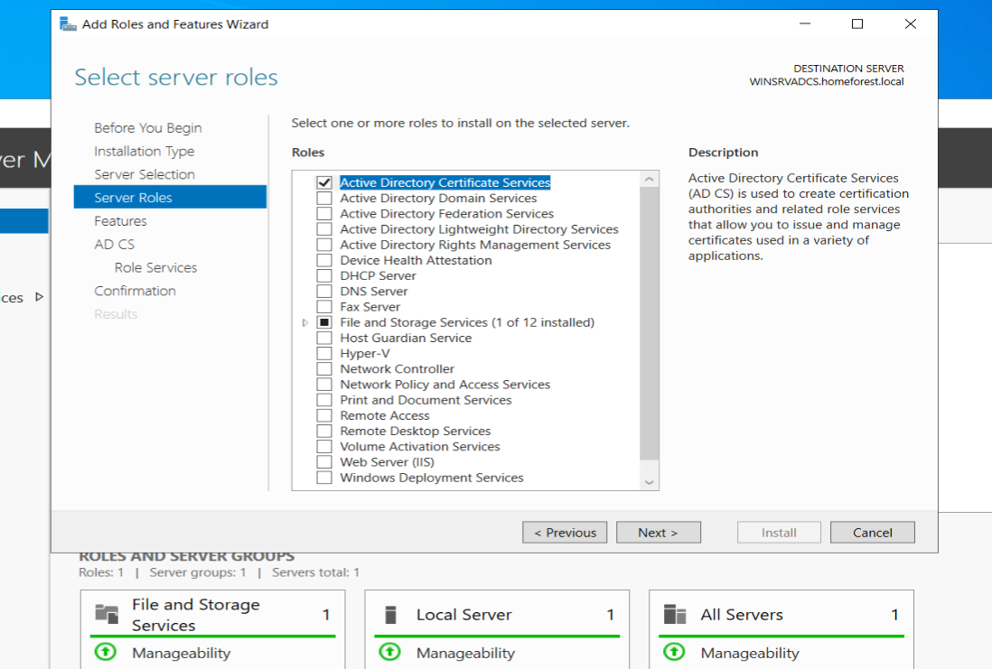

After this server was joined to my domain controller, I then began my ADCS installation and configuration in server manager by adding roles and features, choosing ADCS.

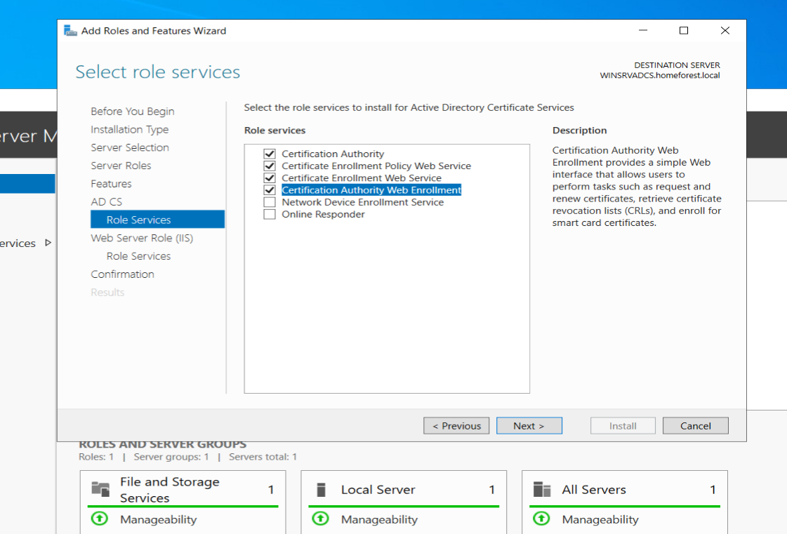

The role services within ADCS needed were certification authority, certificate enrollment policy web service, certificate enrollment web service and certification authority web enrollment.

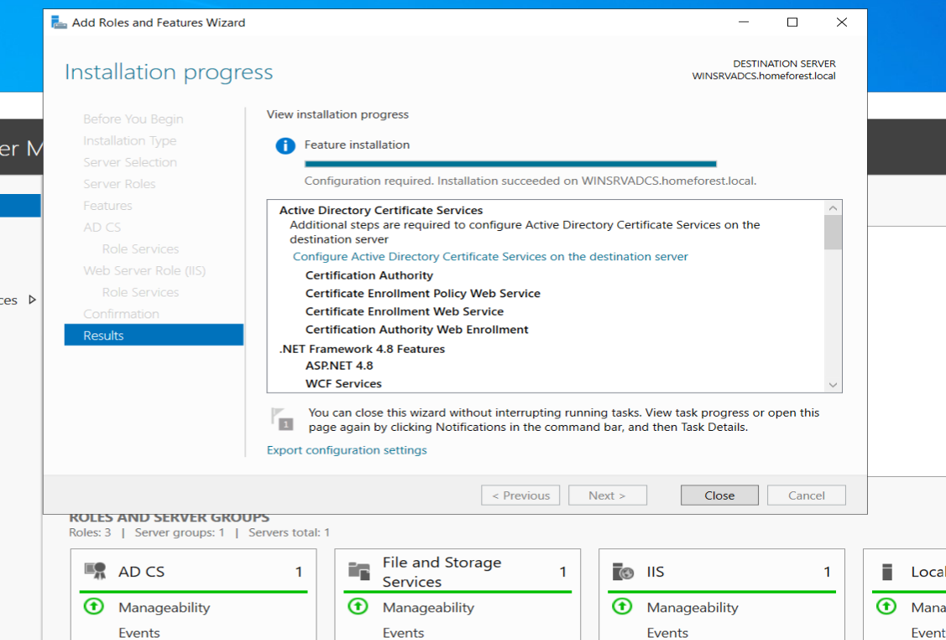

My installation was successful.

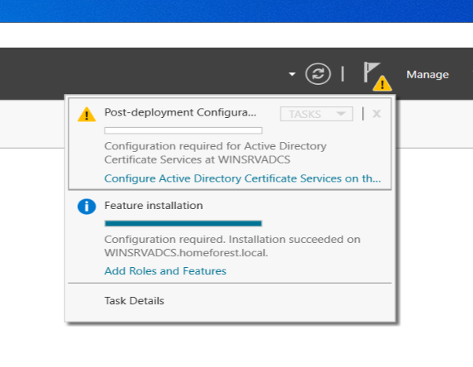

I then needed to finish the configuration of ADCS by clicking “configure active directory certificate services…”

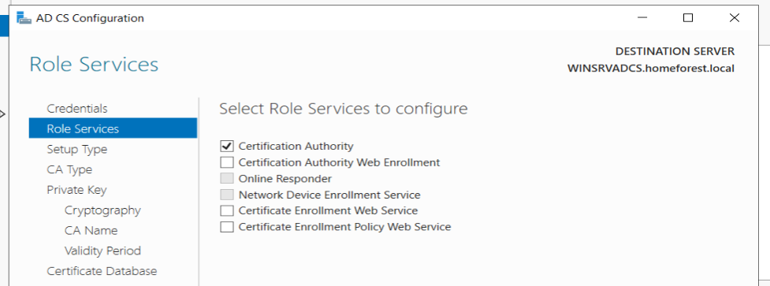

The first role service I configured was certificate authority.

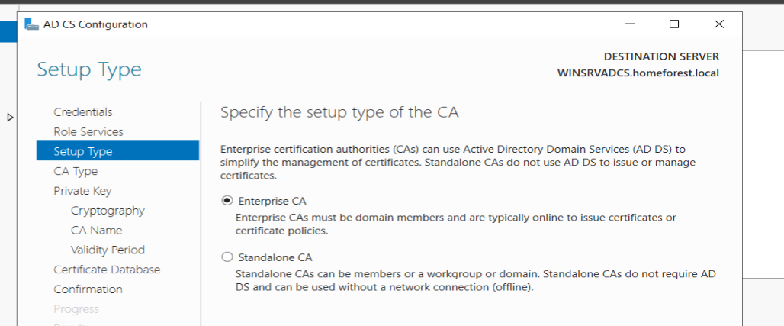

The setup type needs to be an enterprise CA otherwise you can’t. continue.

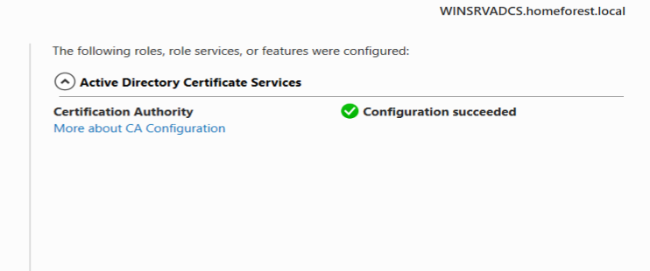

After configuring certificate authority with what I chose, it succeeded.

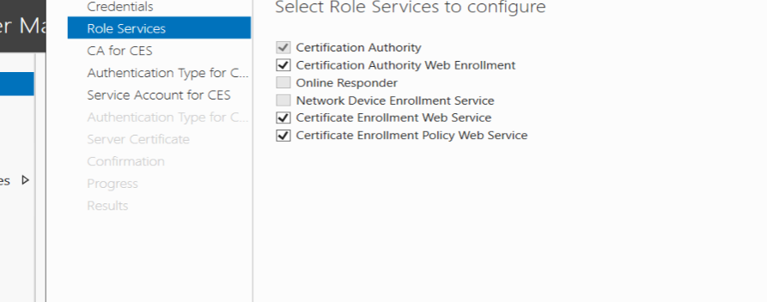

I then configured the rest of the role services; being certification authority web enrollment, certificate enrollment web service and certificate enrollment policy web service.

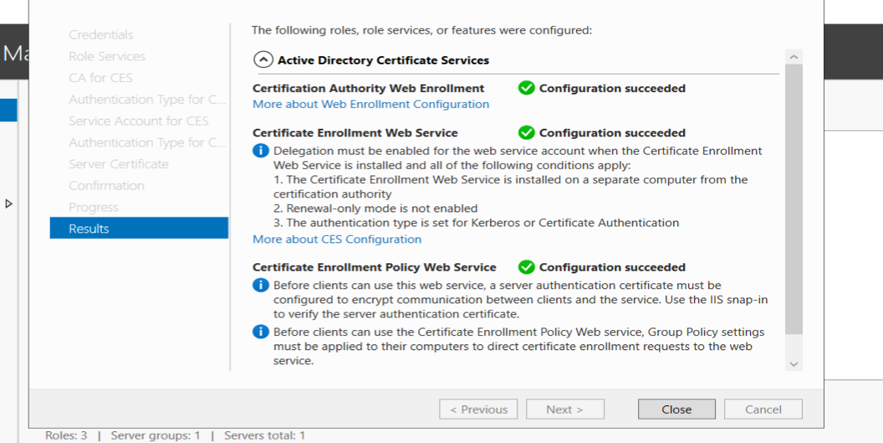

The confirmation with all options I chose that the configuration was successful.

CentOS/Web Server



The first thing I needed to do in CentOS was install httpd, php, php-mysql, nano, samba, mariadb, mod_ssl and cifs-utils to do all my configurations when I get to them. The command to install everything was **sudo yum install httpd php php-mysql nano samba samba-client mariadb mariadb-server mod_ssl cifs-utils.**

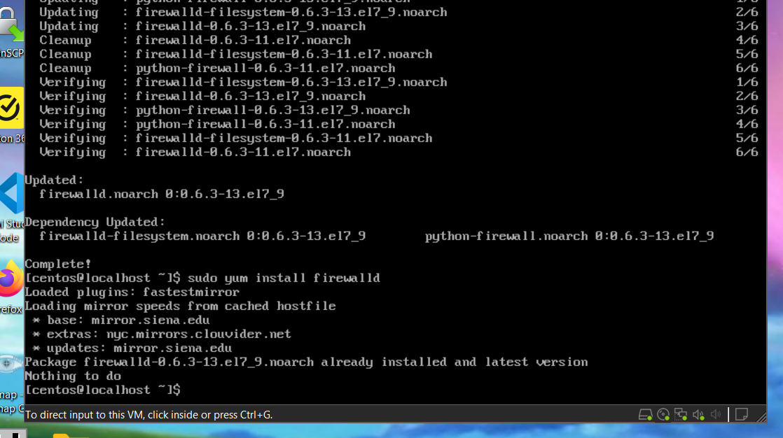

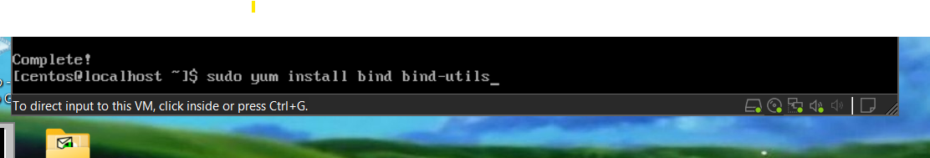

I also had to install firewalld and BIND by typing **sudo yum install firewalld** and **sudo yum install bind bind-utils.**

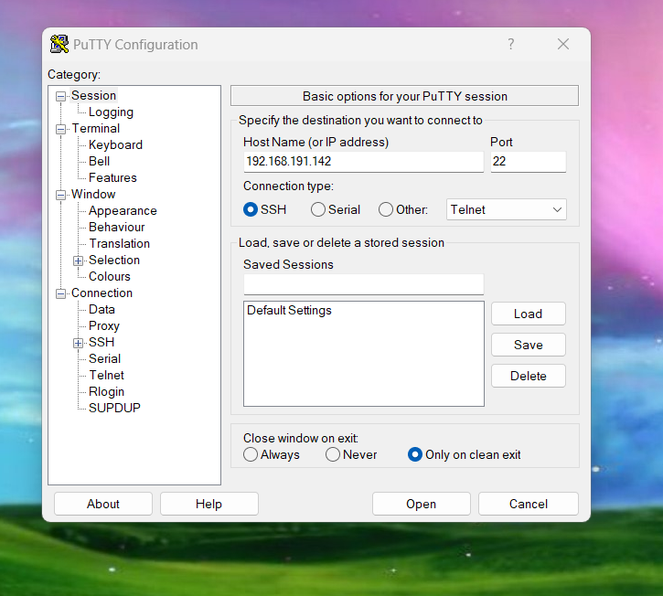

Next, I went into Host Only mode for my CentOS machine and opened PuTTY to access my machine easier and to do my configurations for everything. 192.168.191.142 is my CentOS machine IP.

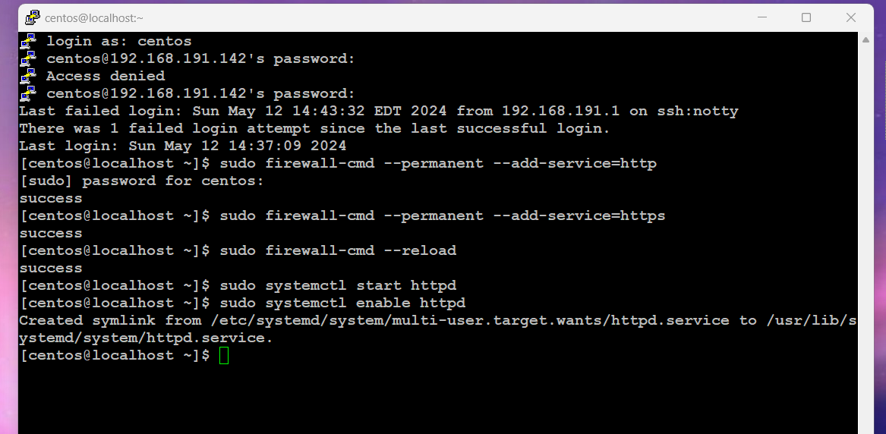

After installation, I configured the firewall settings for http and https, and enabled the apache service. The commands to do this:

**sudo firewall-cmd --permanent --add-service=http**

**sudo firewall-cmd --permanent --add-service=https**

**sudo firewall-cmd –reload**

**sudo systemctl start httpd**

**sudo systemctl enable httpd**

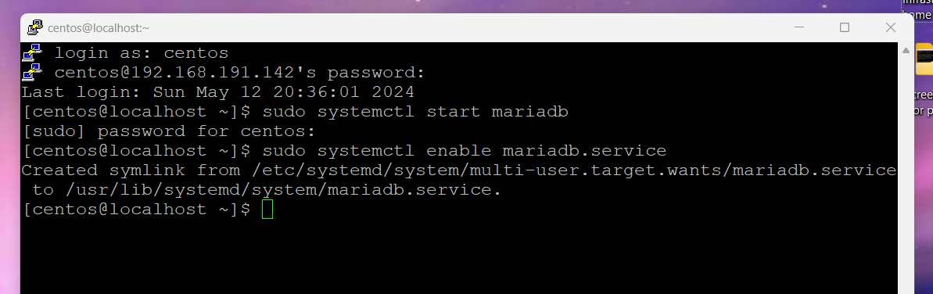

Next, I began to configure MySQL. The commands **sudo systemctl start mariadb** and **sudo systemctl enable mariadb.service** start and enable the service.

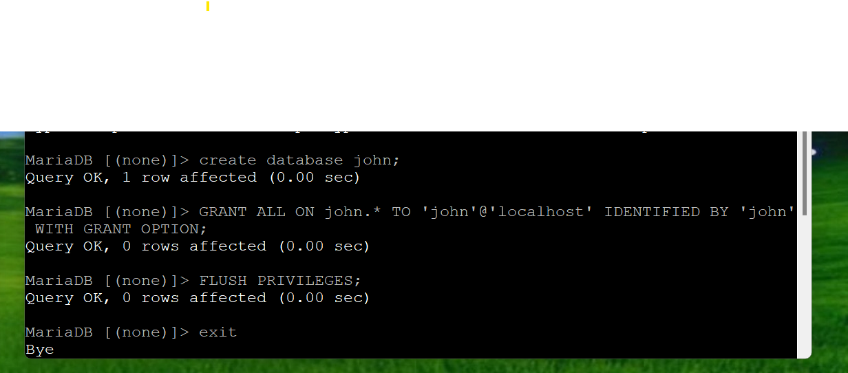

I created a database for John by typing **create database john;**.

**Grant all on john.* to ‘john@localhost’ identified by ‘john’ with grant option;** gives john privileges.

**Flush privileges** flushs the privileges.

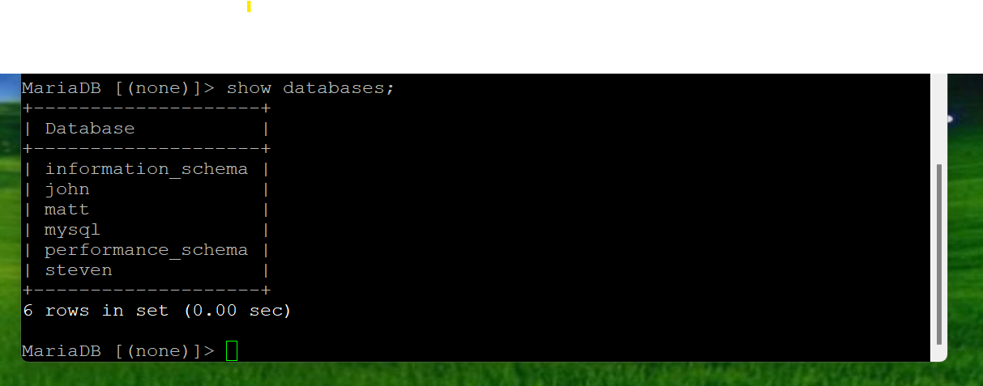

I then created databases for matt and steven using the same command layout for john.

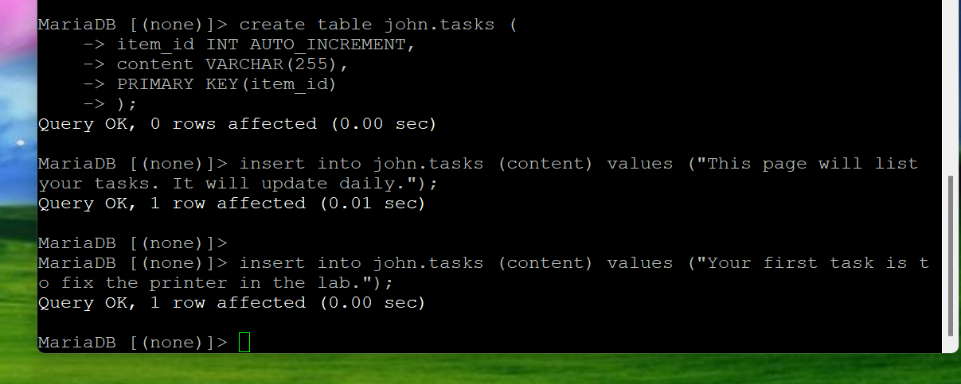

I then created a page for John to access for tasks he must do. The commands to do this:

**CREATE TABLE john.tasks (**

**item_id INT AUTO_INCREMENT,**

**content VARCHAR(255),**

**PRIMARY KEY(item_id)**

**);**

The following was entered to insert rows for John.

**INSERT INTO john.tasks (content) VALUES ("This page will list your tasks. It will update daily.");**

**INSERT INTO john.tasks (content) VALUES ("Your first task is to fix the printer in the lab.");**

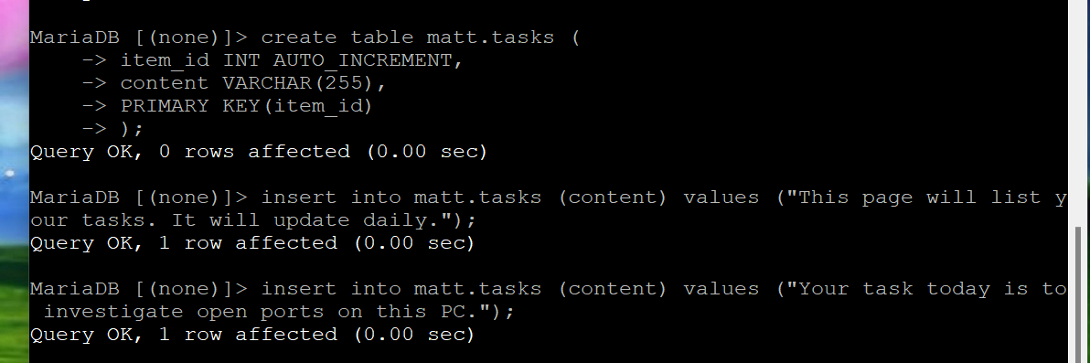

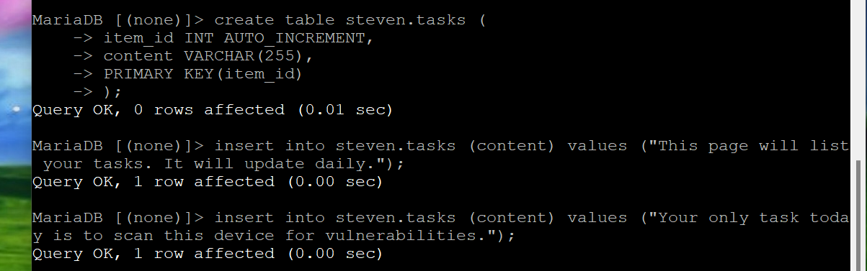

I did the same thing and followed the same layout for Matt and Steven.

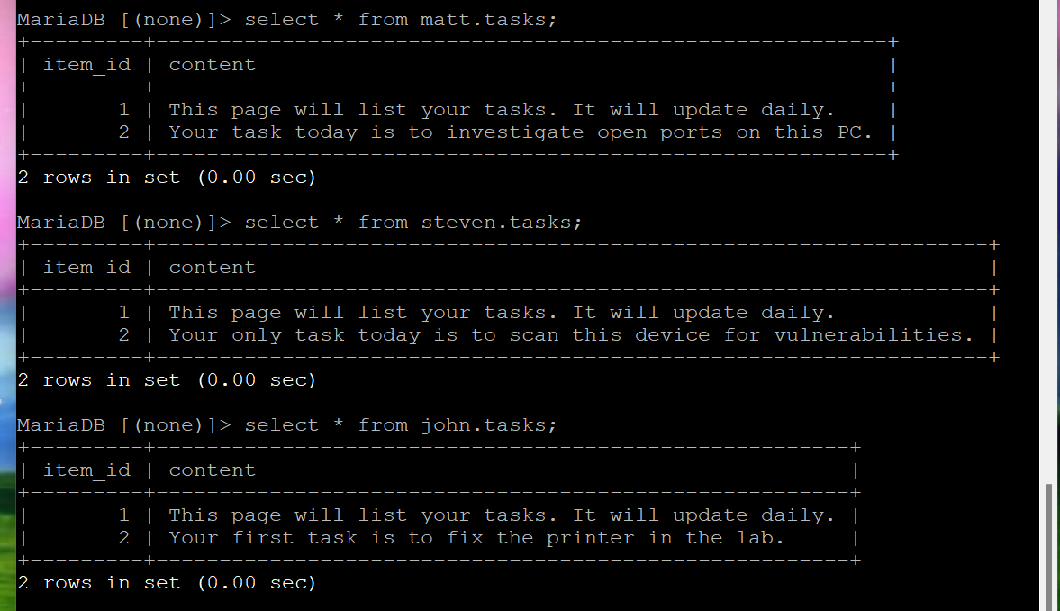

When I typed in **select * from <user here>.tasks;**

It shows what will be displayed on the webpage.

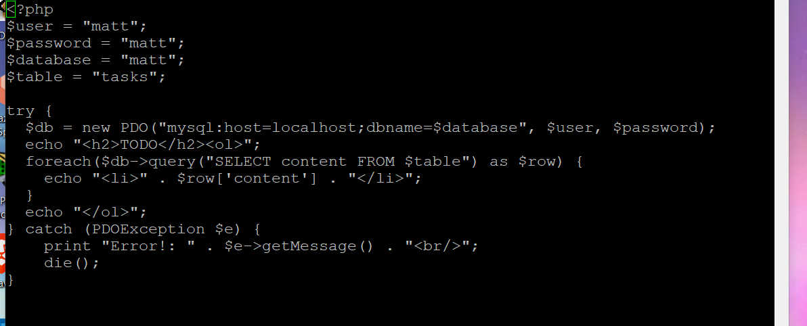

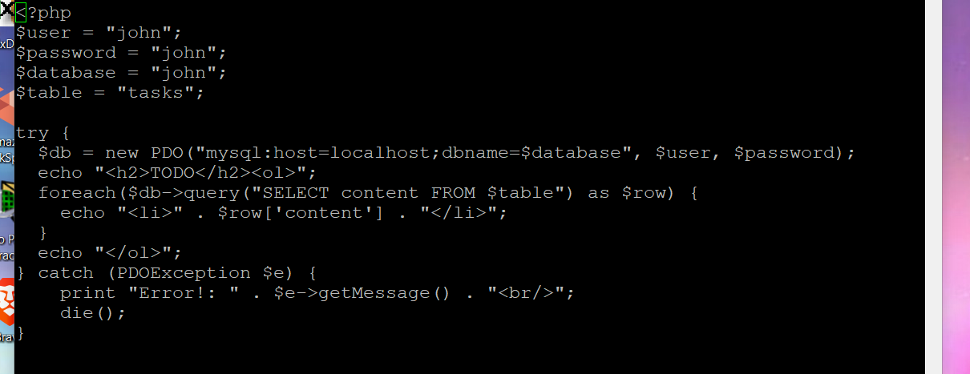

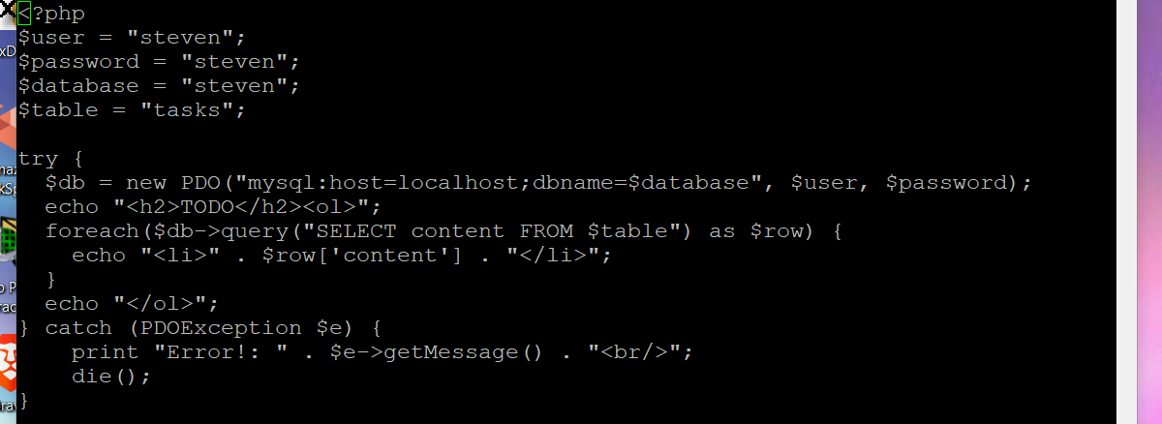

These 3 screenshots each show steven’s, john’s and matt’s PHP configuration file.

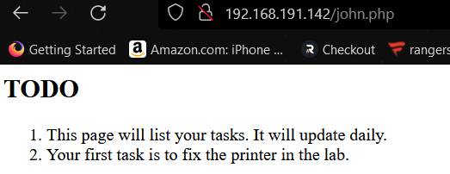

John’s page. This is accessed by typing in my centos IP/john.php.

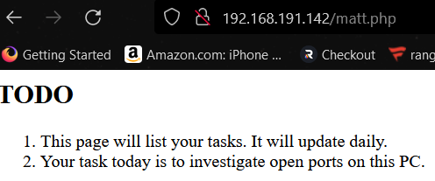’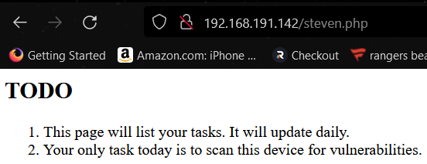

Above listed are Matt’s and Steven’s pages.

Trusted Certificate for Apache

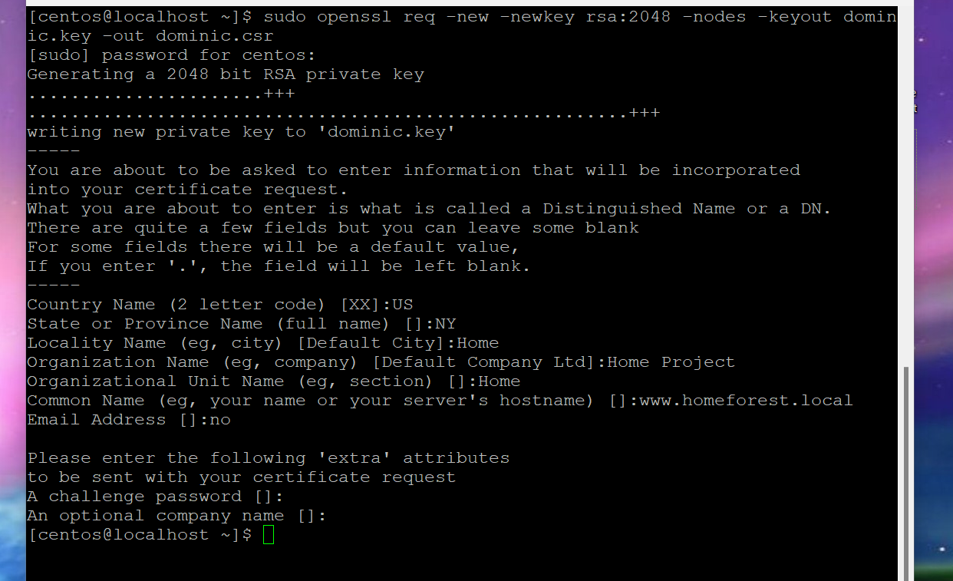

The first thing I had to was create a new certificate request by typing in **sudo openssl req -new -newkey rsa:2048 -nodes -keyout dominic.key -out dominic.csr.**

My common name is [www.homeforest.local](http://www.homeforest.local). This needs to be exact to my DNS entry created earlier.

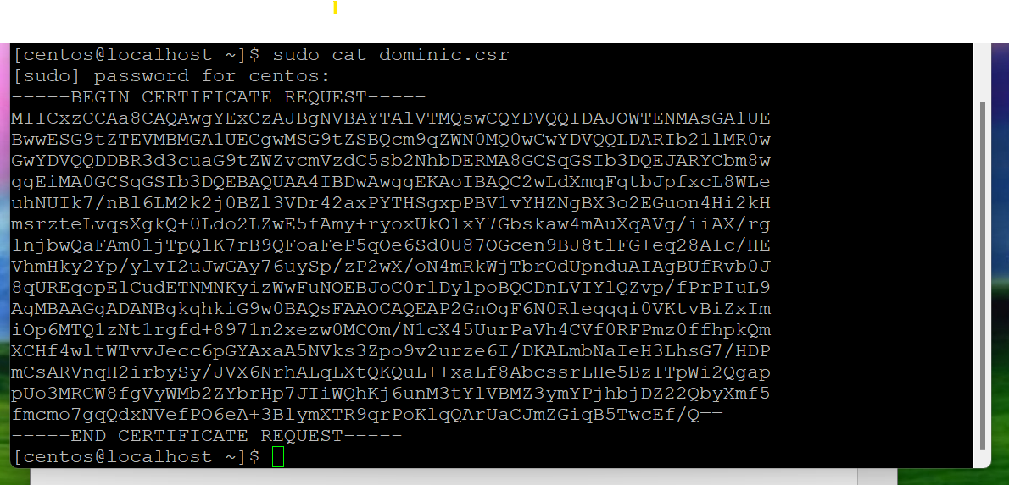

I then typed in **sudo cat dominic.csr** and copied the certificate request.

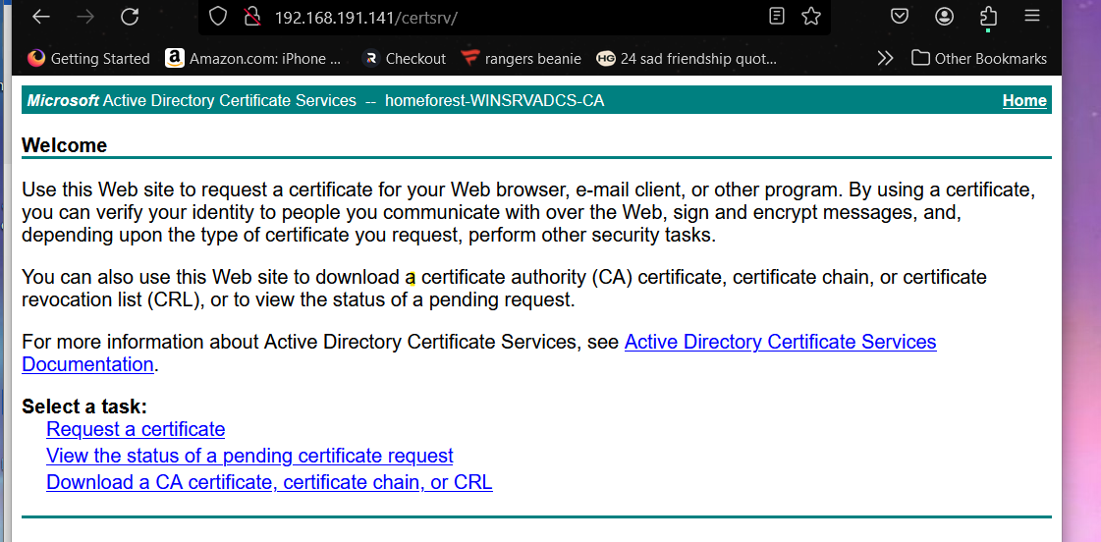

Then in my local web browser, I typed in my ADCS server IP/certsrv. I then requested my certificate, made it an advanced request, and pasted the certificate request, downloading the certificate as a base 64.

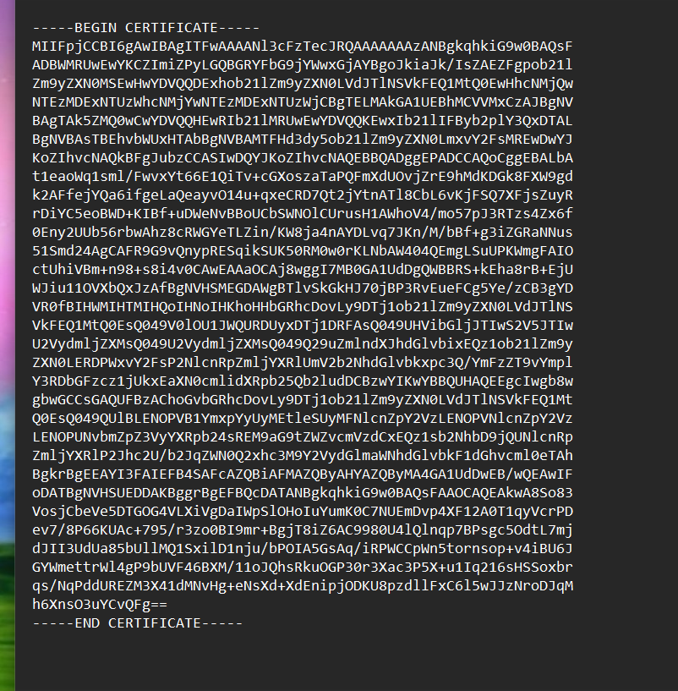

I opened the downloaded certificate in notepad and copied it.

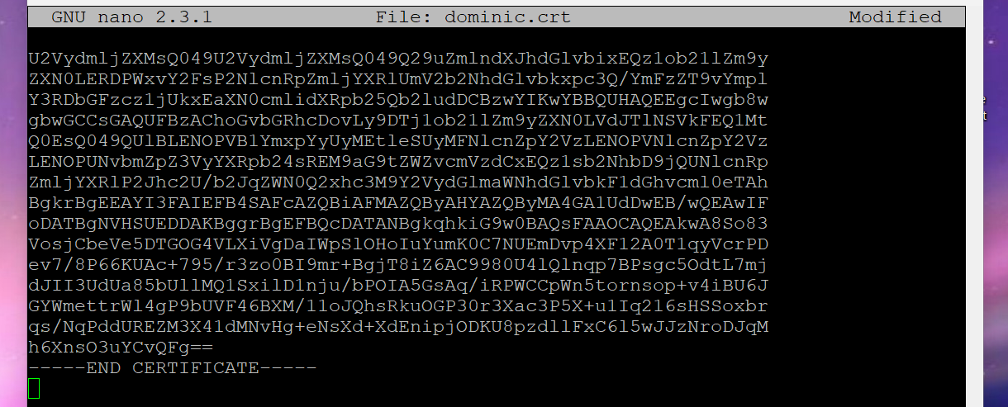

Back to centos, I created a .crt file by typing **sudo nano dominic.crt** and then I pasted the certificate and saved the file.

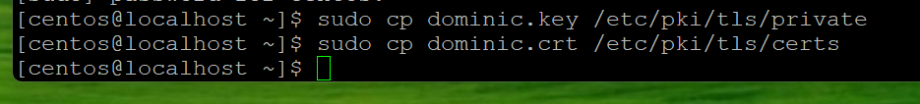

I then copied the .key and .crt to the directories listed above by typing:

**sudo cp dominic.key /etc/pki/tls/private**

**sudo cp dominic.crt /etc/pki/tls/certs**

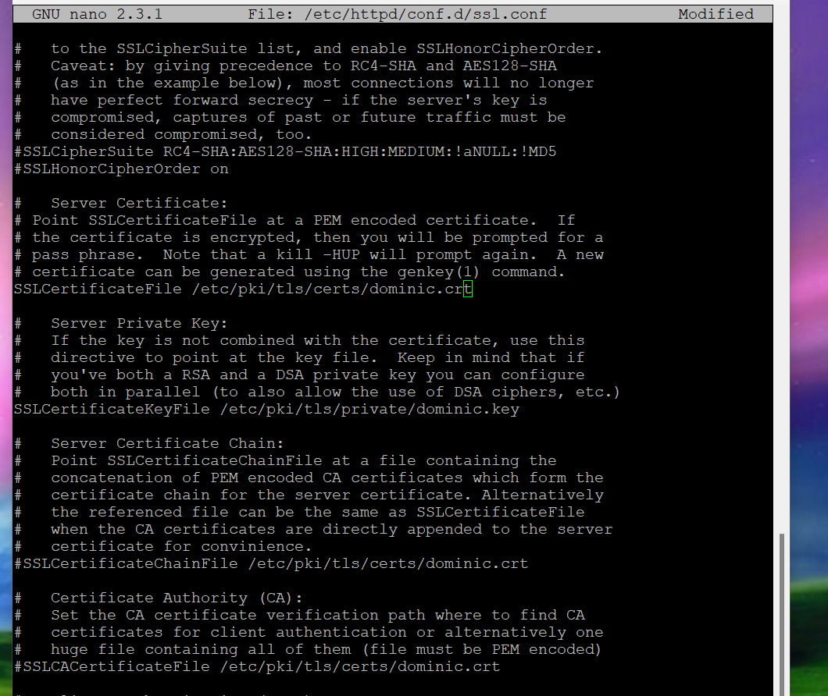

I then needed to open the ssl configuration file by typing **sudo nano /etc/httpd/conf.d/ssl.conf** and where it states server certificate, server private key, server certificate chain, and certificate authority, I had to change the files to the ones that I created as listed above.

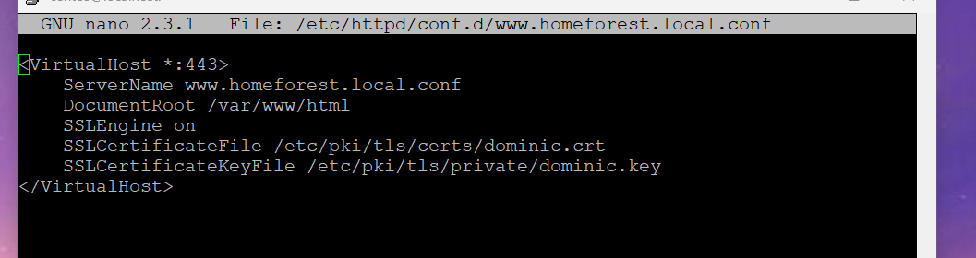

I then needed to created a configuration file in this directory to have my web server redirect to HTTPS, and have the certificate file and certificate key file be the ones that I created as well. The command to create this file was **sudo nano /etc/httpd/conf.d/www.homeforest.local.conf**

I then saved the file.

Then I restarted apache by typing **sudo systemctl restart httpd.**

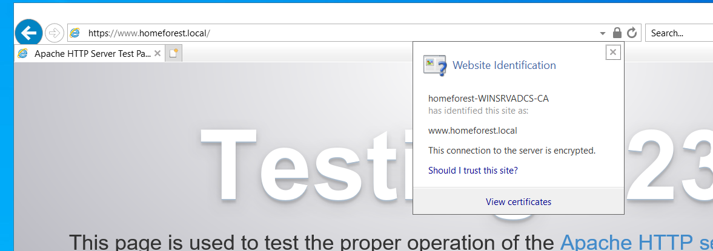

Going into windows, in internet explorer specifically, when typing in <https://www.homeforest.local/> and refreshing the page, it shows the certificate is valid and trusted.

BIND ON CENTOS

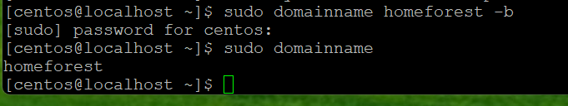

The first thing I did was setting my domain name on CentOS to homeforest. This was done by typing **sudo domainname homeforest -b,** and **sudo domainname** to verify.

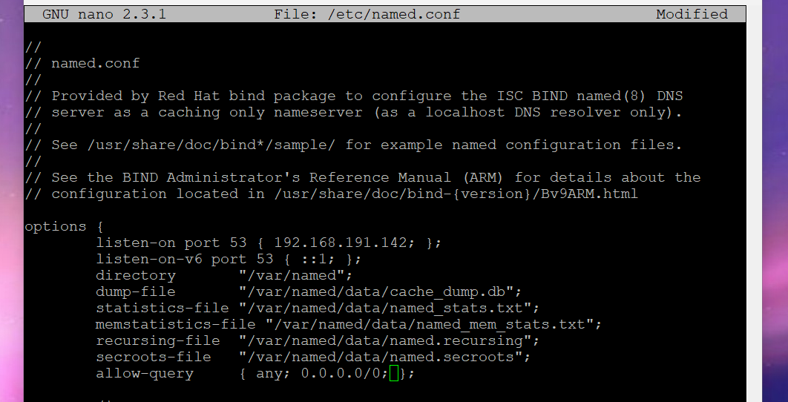

Then I opened the configuration file by typing **sudo nano /etc/named.conf.** I allowed it to listen on port 53, being DNS, pointing to my CentOS IP and I allowed queries from anybody.

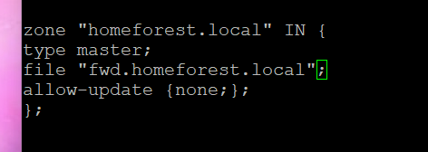

I then added my zone at the bottom of the file and saved it.

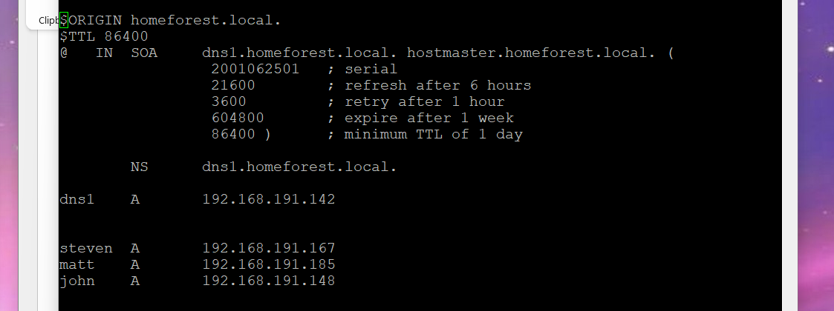

Then I created a forward lookup zone file by typing **sudo nano /var/named/fwd.homeforest.local.** The layout I set to this. I added entries for steven, matt and john with different IPs and saved the file.

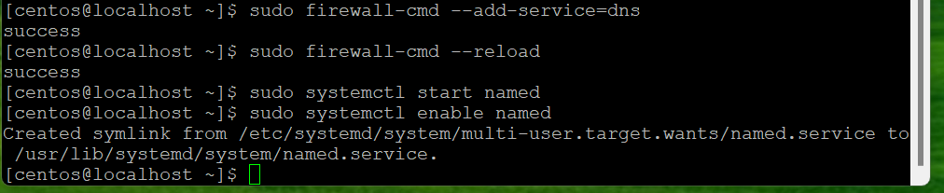

I then configured the firewall settings typing **sudo firewall-cmd –add-service=dns** and **sudo firewall-cmd –reload.**

**sudo systemctl start named** & **sudo systemctl enable named** started and enabled the BIND service.

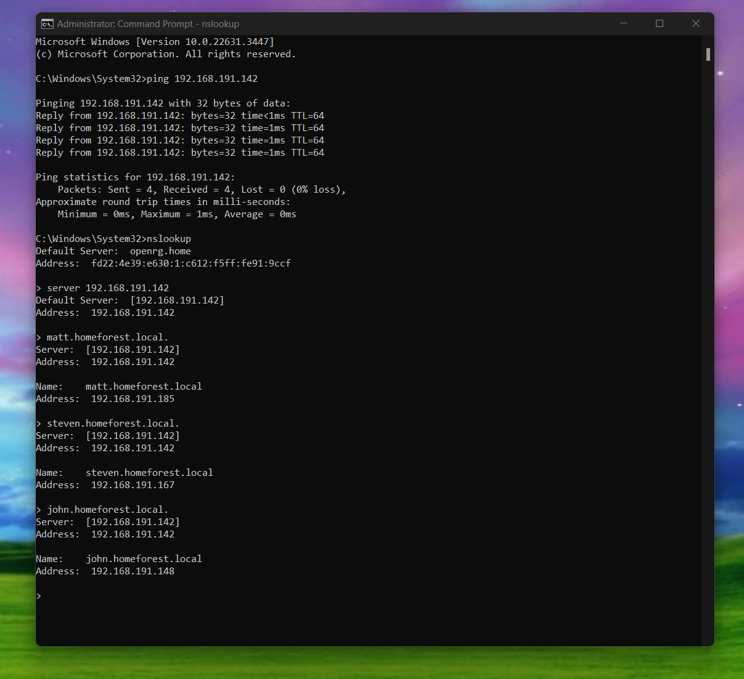

To test to make sure my DNS server is working, I opened up CMD as administrator from my host machine. I pinged my CentOS machine to ensure that there is a connection. Then I started nslookup, and entered my CentOS server IP. I typed in all of the names I configured in my forward lookup zone file, john, matt and steven, and their names all resolve to their IP address assigned to them.

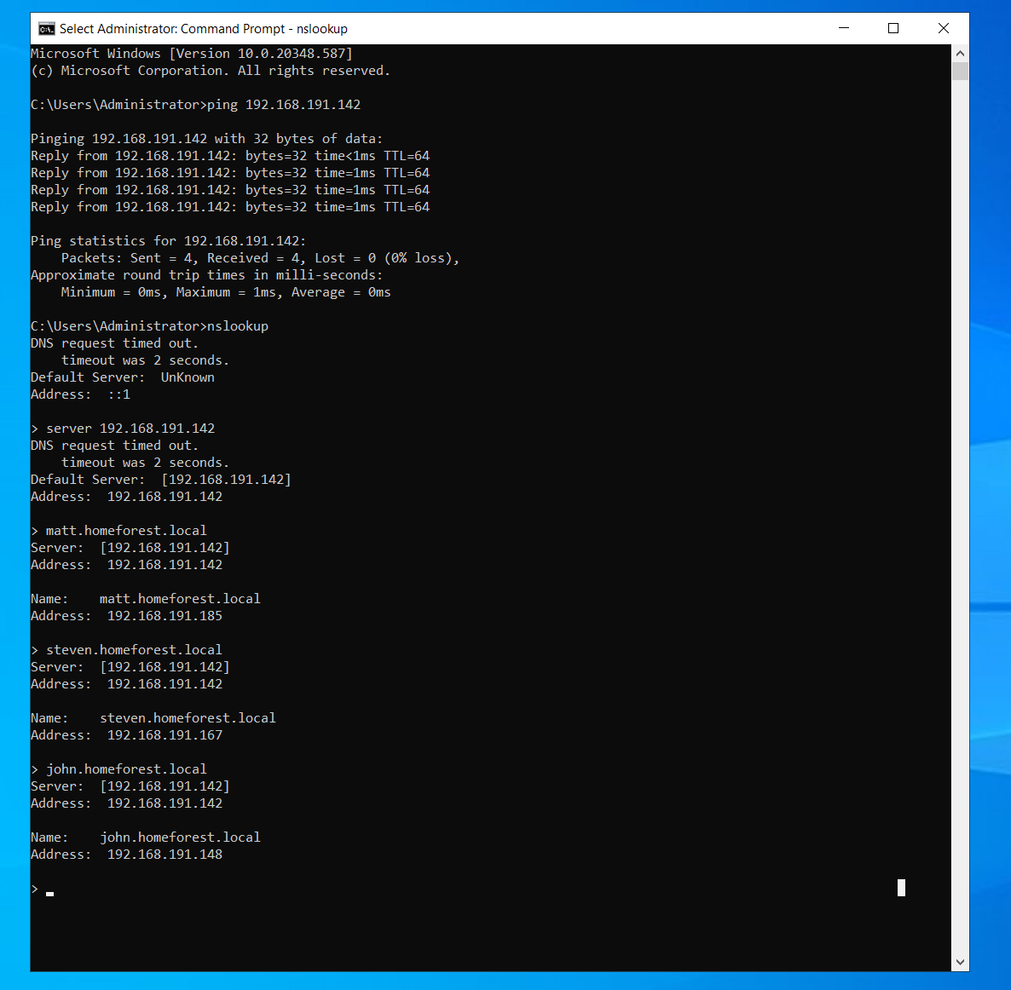

I did the same thing on my windows server machine to ensure DNS is working.

SAMBA

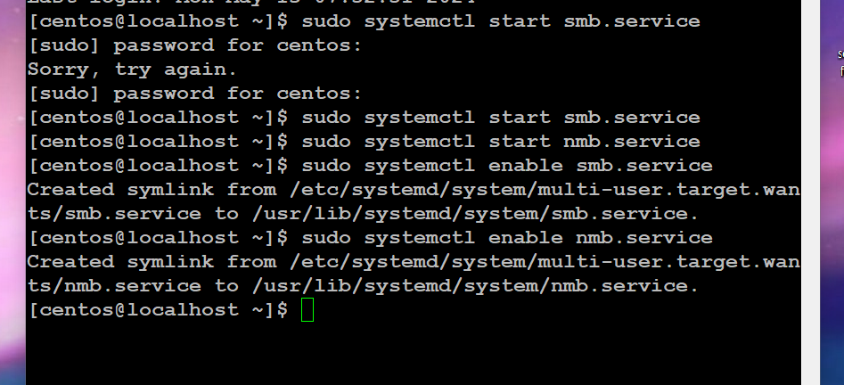

The first task I did was enable and start the samba service. The commands were the following:

**sudo systemctl start smb.service**

**sudo systemctl start nmb.service**

**sudo systemctl enable smb.service**

**sudo systemctl enable nmb.service**

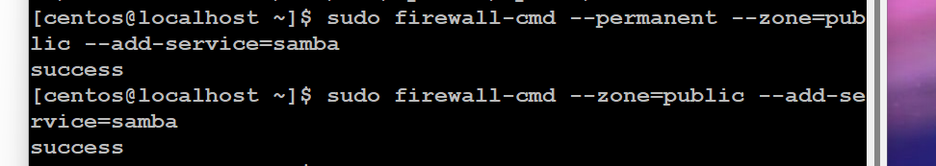

Next, I configured the firewall settings. The commands were:  
**sudo firewall-cmd --permanent --zone=public --add-service=samba**

**sudo firewall-cmd --zone=public --add-service=samba**

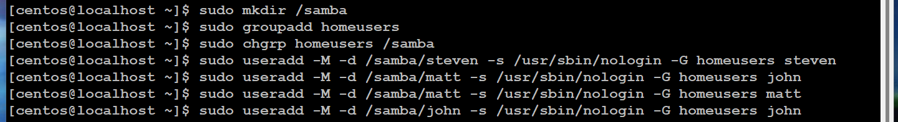

Then I created the samba directory, a group, gave that group ownership, and created my users. The commands were:

**sudo mkdir /samba**

**sudo groupadd homeusers**

**sudo chgrp homeusers /samba**

**sudo useradd -M -d /samba/<user here> -s /usr/sbin/nologin -G homeusers <user here>**

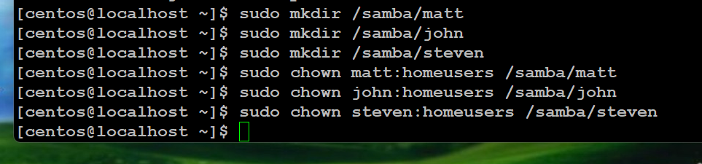

Then I created directories for each user and gave that user ownership of their directories. The commands were:

**sudo mkdir /samba/<user here>**

**sudo chown <user here>:homeusers /samba/<user here>**

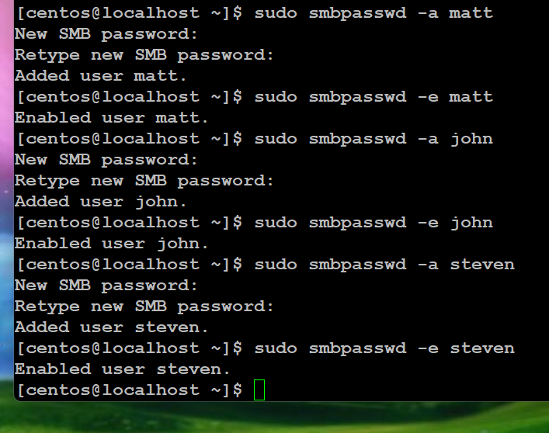

Then I created passwords and enabled my users. Those commands were:

**sudo smbpasswd -a <user here>**

**sudo smbpasswd -e <user here>**

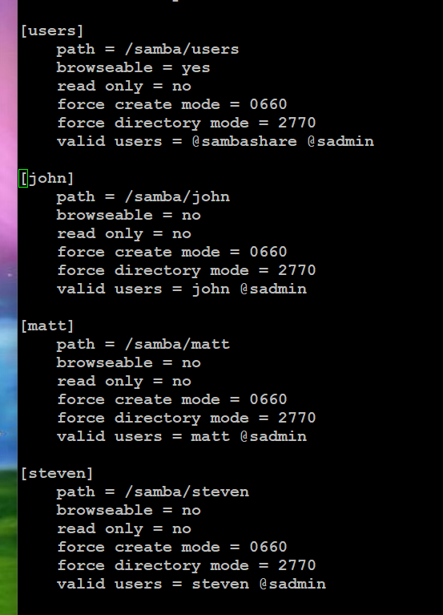

I then had to open the samba configuration file by typing **sudo nano /etc/samba/smb.conf** and add the entries listed for each user.



**sudo mkdir /samba/users** created a users directory. **Sudo systemctl restart smb.service** and **sudo systemctl restart nmb.service** restarted the service.

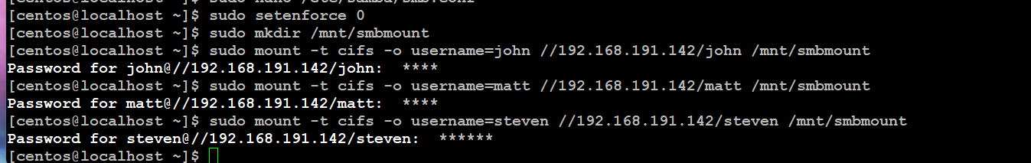

**sudo setenforce 0** disables SELinux. This is important because samba won’t work unless you temporarily disable SElinux. You can permanently disable it but in this instance I didn’t do that.

**sudo mkdir /mnt/smbmount** created a mount directory.

**sudo mount -t cifs -o username=<user here> //<ip of centos machine>/<user here> /mnt/smbmount** created the mount for each user.

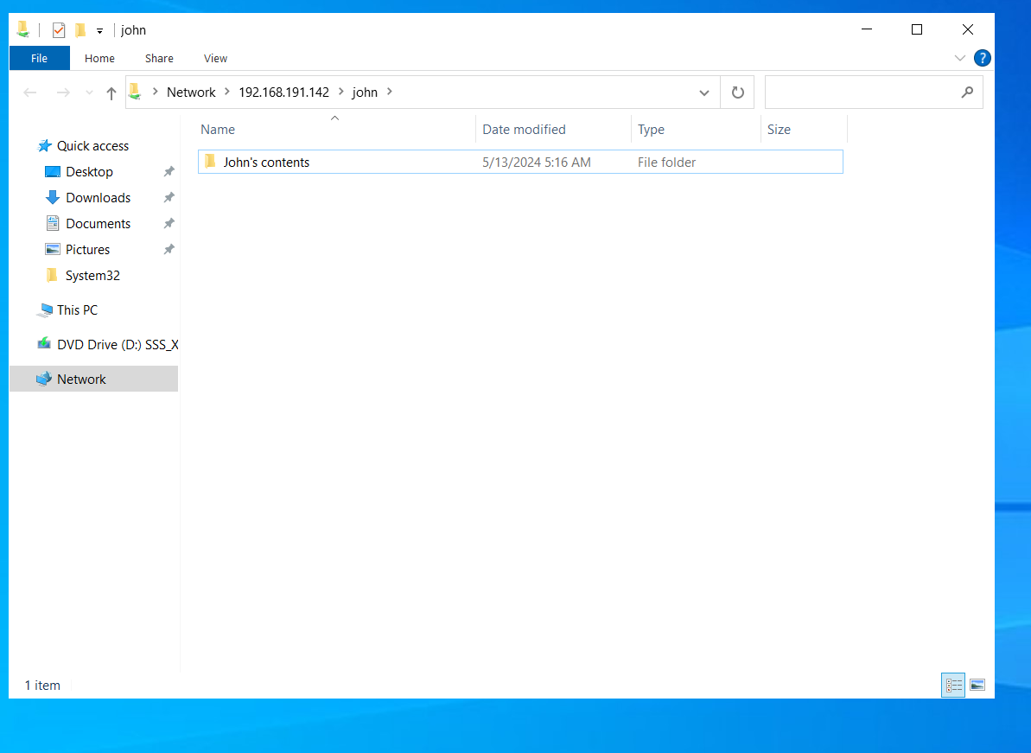

In different windows machines, I typed in run, the IP of my centos machine\<user here>\, logged in with their credentials created in the configuration, and then I was able to access their share.

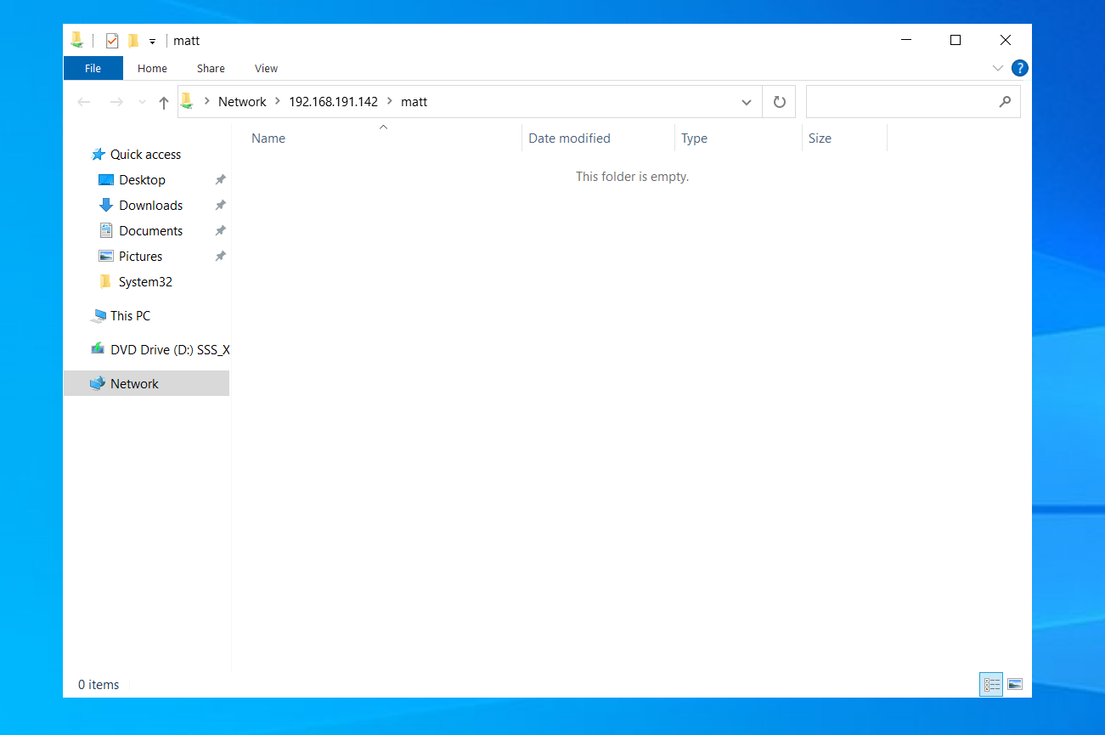

Matt’s share.

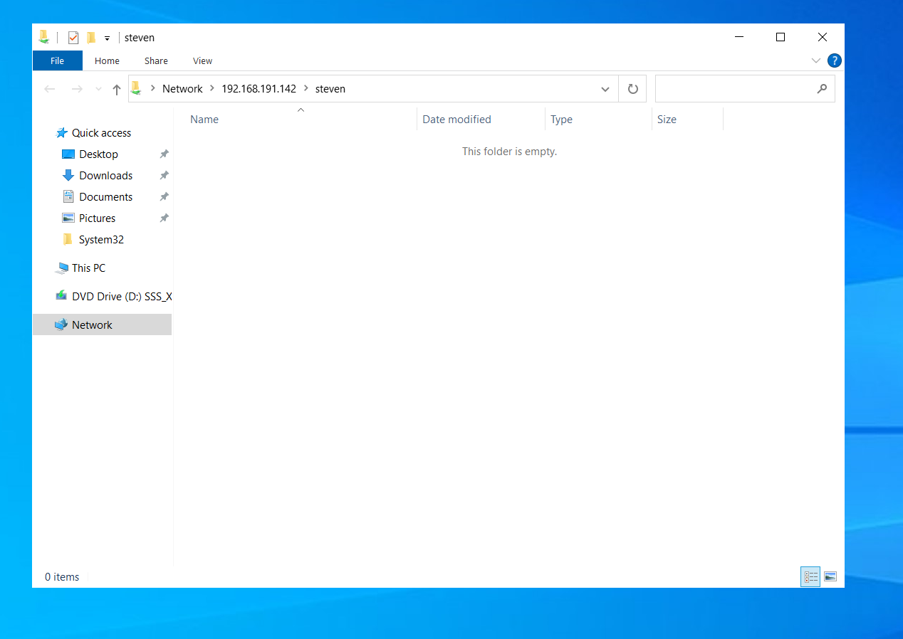steven’s share.

Windows File Sharing

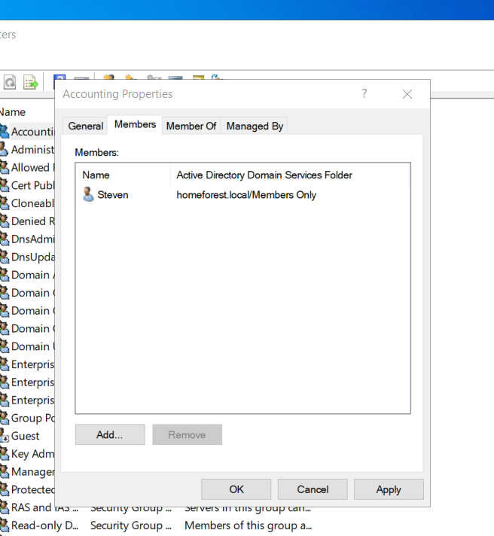

The first thing I did was create a group called Accounting in Active Directory. This was done by clicking the users tab, right clicking anywhere, clicking new, then group, naming it accounting. Then I added Steven to the group. This was done by right clicking the group, opening its properties, and adding Steven.

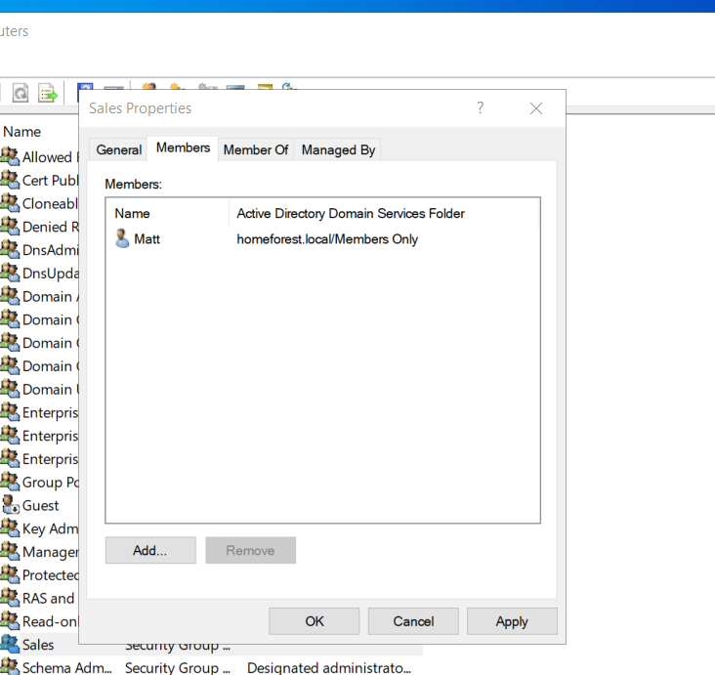

Then I created a group called Sales and added Matt to the group using the same process.

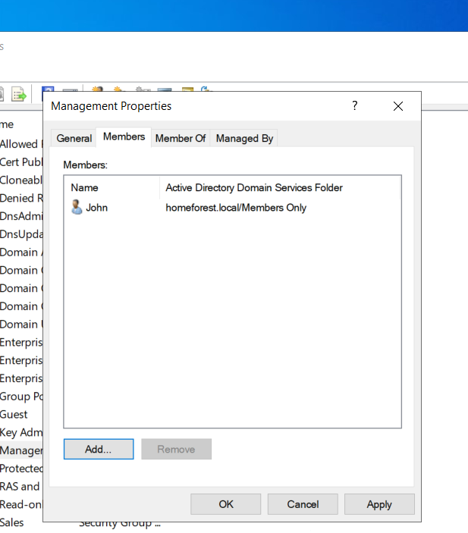

The same process for John, and the Management group.

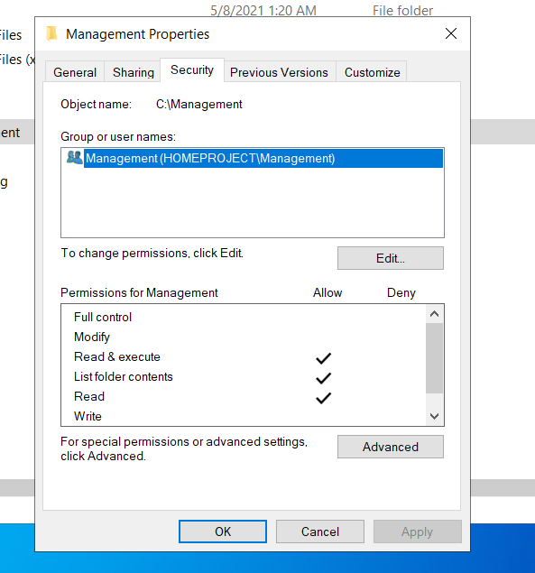

I then created a folder for Management in the C drive, and assigned the management group the only group to be able to do anything with the folder, in this case, only giving the group read & execute, list folder contents and read. How this was done was by the security tab, then advanced, disabling inheritance, removing all inherited permissions from the object, then “add”, and select a principal, that being the group for the folder.

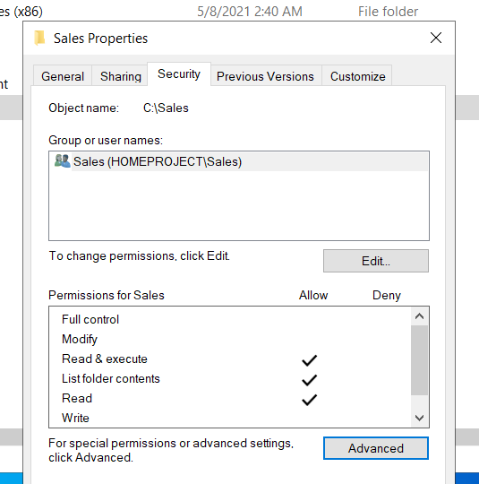

I then created a folder for Sales and assigned the Sales group the same permissions as Management, along with the same process.

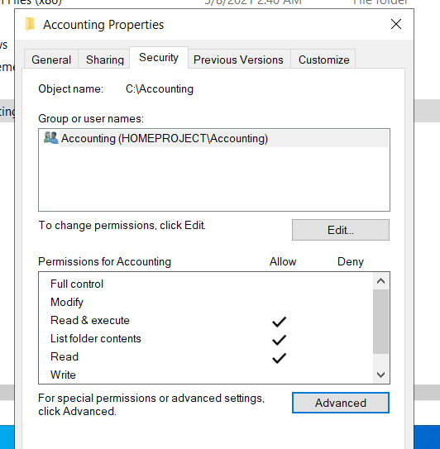

The same process for the Accounting group similar to Management and Sales.

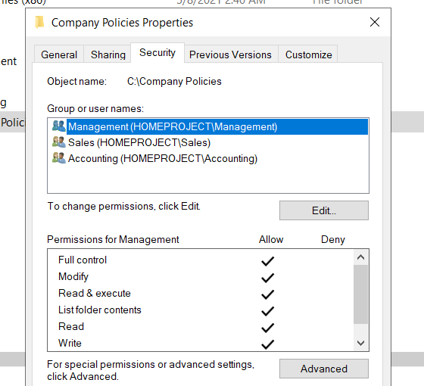

Then, I created a Company Policies folder, and gave management full control over it.

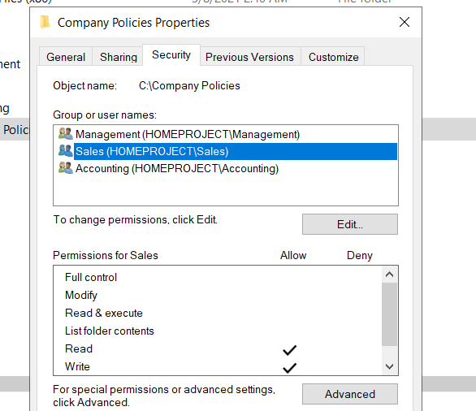

Sales can only read and write.

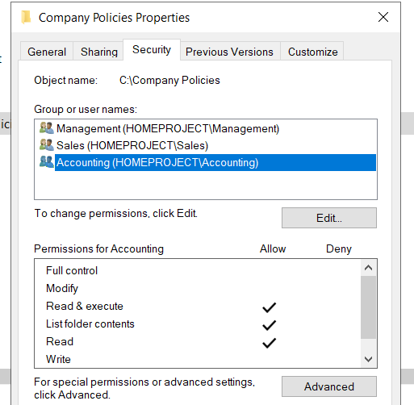

Accounting can only read and execute, list folder contents, and read.